Short term plan: term 3

Unit of a long term plan: Our health |  | Lesson 51
Teacher name: |  | Karabaeva S
Date: |  | 14.01
Grade: 6 |  | Number present: | absent:
Lesson title | Language Focus. Can for ability and permission.
Learning objectives | 6.1.1.1 use speaking and listening skills to solve problems creatively and cooperatively in groups  6.6.13.1 use might may could to express possibility on a limited range of familiar general and curricular topics  6.3.7.1 use appropriate subject-specific vocabulary and syntax to talk about a limited range of general topics
Lesson objectives | Learners will be able to:  • Learn the form and use of can for ability and permission.  • Write sentences about your abilities using can.  • Learn how to request, give and refuse permission.  • Practise a dialogue in which you ask for permission.
Value links | Fairness – If you value fairness, you might be highly sensitive to situations at school or in the workplace where a teacher or a peer has exhibited favoritism or allowed someone to get away with living by a different set of rules to everyone else.
Plan

Stages / Time | Teachers actions | Students actions | Assessment criteria | Resources
Beginning of the lesson  5 min | Organization moment  1.Greeting.  Ask about the weather.  Warm-up  • Ask individual students questions using can, for example: Can you swim? Can you play the guitar?  • Ask students to find examples of can in the text on page 50.  • Discuss the examples with the class and elicit that we use can to talk about abilities or permission  Lead - In  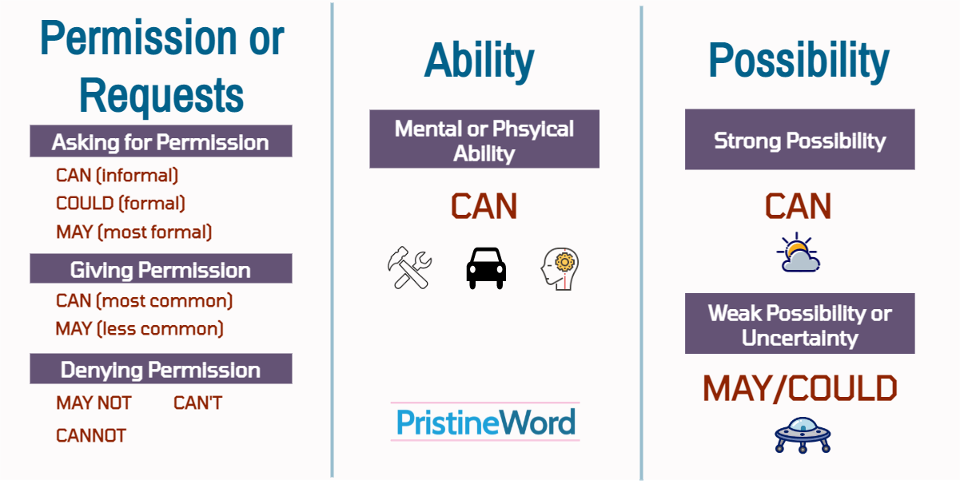 | The wish flower” method helps to start the lesson with good wishes to each other.  The aim: To develop Ss speaking skills and create friendly atmosphere  Efficiency: By telling the wishes they show their appreciations .  Describe and imagine the pictures  Students say different words from the picture | At the organization moment T tries to award active Ss. «The praise» method is used to evaluate Ss with phrases like:  “Good job!  Well done!”  Formative Assessment    Good job! | CD 1  Pictures  PPT
Middle of the lesson  Presentation part.  35 min | Ex: 1 P: 59  • Ask students to read the sentences carefully, then answer the questions.  • Make sure that students understand the meaning, for example by asking them to translate the sentences into their own language  Differentiation:  «Verbal support» method is used to help Students use new words in the text.  Ex: 2 P: 59  • Students identify the use of can in the sentences individually. In a weaker class, check understanding by doing the first item together as an example.  • Ask students to compare their answers in pairs before you check with the class  Ex: 23 P: 59  • Read the example with the class and elicit one or two more examples of sentences using can for ability.  • Go through the ideas in the box and check understanding. In a stronger class ask students to write more sentences, using their own ideas.  • Students write their sentences individually. In a weaker class, check students’ answers at this point before they go on to ask and answer. | Students look at the sentence and answer the question  ANSWERS:  1 a and d  3 can’t  2 b, c and e  4 No, we don’t.  Students look at the sentences and write P (permission) or A (ability)  ANSWERS:  1 A  2 P  3 A  4 P  5 P  6 A  Students write sentences about your ability  ANSWERS:  Students’ own answers  I can play chess.  I can speak three languages  I can run one killometre | Assessment criteria  - Learn the form and use of can for ability and permission.  Descriptor:  - look at the sentence and answer the question  Peer assessment: answer key  Assessment criteria:  - Write sentences about your abilities using can.  Descriptor:  -write sentences about your ability  -Make CCQ questions  Yes / No |   Cards  Student’s book  Workshets
End of the lesson  5 min | Home task:  Ex: 2 P: 41 WB | 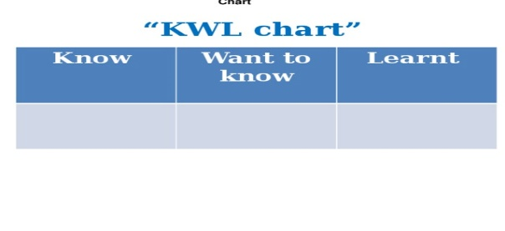 |  | Poster Success  

