Short term plan

Module 3: My school |  | School: A.Karsakbayev secondary school
Date: 08.11.18 |  | Teacher name: Ulpan Kakimgaly
CLASS: 2 «Ғ» |  | Number present: | absent:
Learning objectives(s) that this lesson is contributing to | 2.L1 understand a range of short basic supported classroom instructions  2.UE11 use have got+noun to describe and ask about possessions
Lesson objectives | All learners will be able to:  respond to some prompts about classroom objects and pronounce and spell some words correctly
Most learners will be able to:
respond to most prompts about classroom objects and pronounce and spell most words correctly

Some learners will be able to:
respond to all prompts about classroom objects with correct word stress on longer words and spell most words correctly with little support

Language objective | Listening and speaking; This is ….. schoolbag, sharpener, ruler, desk
Assesment criteria | Pupils say words correctly;  Draw pictures with right color;  to know writing and reading new words;
Values | Being carefully with their school objects and their classroom, school
Cross curricular links | Art
Previous learning | Counting and measuring
Plan
Planned timings | Planned activities |  |  | Smiles  Resources  Teacher  Notes
Beginning the lesson  5-7 min | Greetings: Good afternoon children!  Good afternoon teacher!  How are you today?  We are fine!  Checking the hometask.  Presentation lesson objective and theme for today  Point to a schoolbag, a pen, a pencil, a book, a ruler and a rubber at random and ask individual pupils to name the items. Ask the rest of the class for verification. Play the I’m ready for school song from the previous lesson (Track 32 CD1). Invite the pupils to sing along.  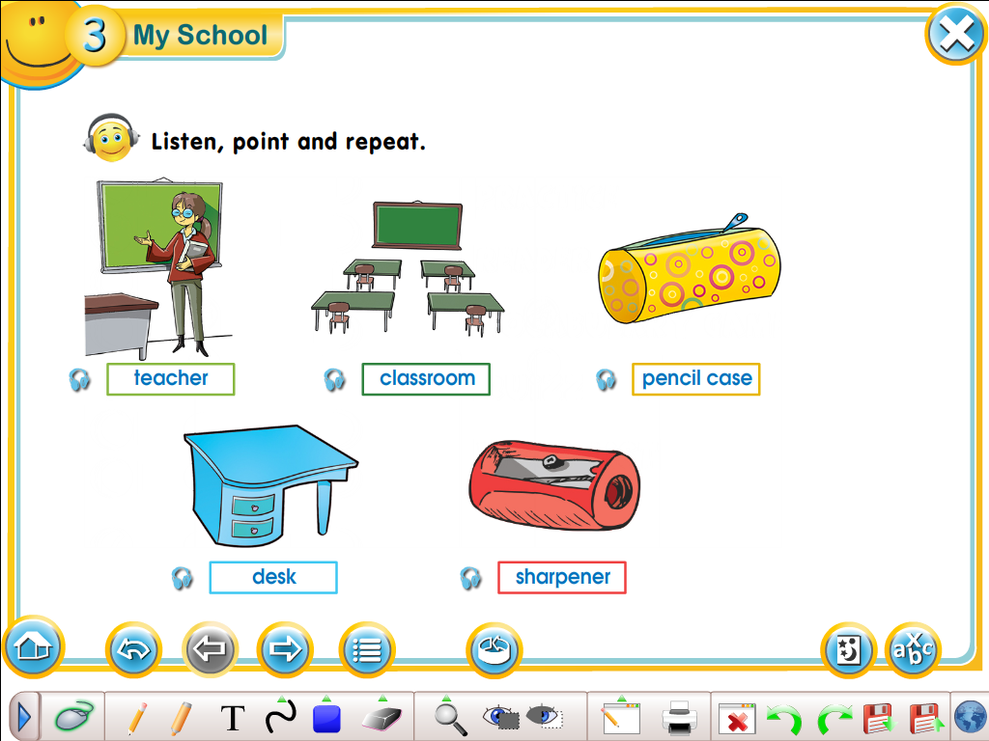 |  |  | Track 32 CD1  School Days poster  Track 33 CD1

Presentation and practice | Task 1 Colour. Point and say.  Colour. Point and say. Refer the pupils to the picture and explain the activity. Allow the pupils some time to colour the picture. Then ask individual pupils to point to an item and describe it. Repeat with as many pupils as you feel is necessary.  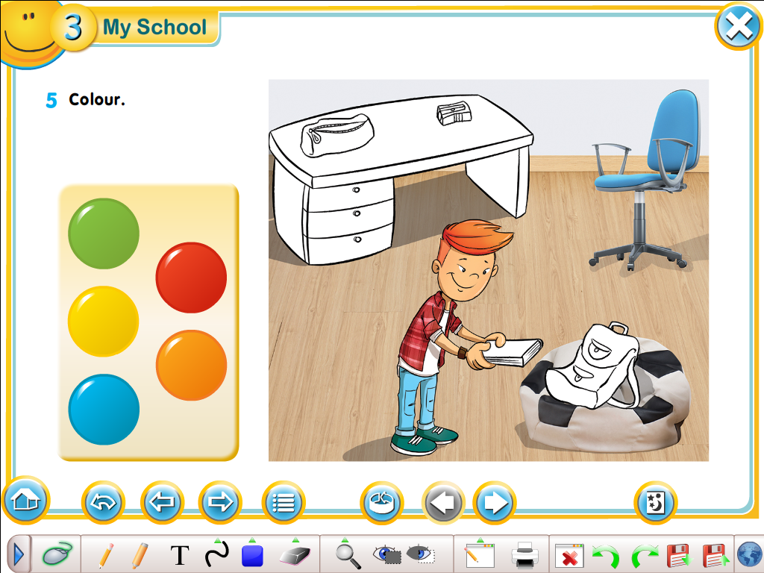  Descriptor: learners  - Say name of objects correctly;  - Choose colour carefully and draw;  FA – Peer Assessment, every students should count how many new words uses his/her partner, FIREWORK for those Students who uses all new words! |  |  | Track 35 CD1
Write some school items on the board with some missing letters. Ask some pupils to come to the board and complete the words. Ask the rest of the class for verification.
Sho_lbag De_k
Boo_ s_arpener
Pe_ no_ebook
Pen_il _lassroom
Ru_ber Ru_er
- Descriptor: find missing letters;
- Write in the words
Ending the lesson | Feedback.  -Green The lesson is clear for me  -Yellow I have got some question  -Red I don’t understand anything  Giving hometask |  |  | 
Additional information
Differentiation – how do you plan to give more support? How do you plan to challenge the more able learners? |  | Assessment – how are you planning to check learners’ learning? | Cross-curricular links  Health and safety check  ICT links  Values links
more emphasis with weaker learners on individual choral drilling  provide more challenge in final task for more able learners with longer words |  | check awareness of sounding and spelling strategies in final task | cross curricular link: the idea of rhyming words in songs

Reflection  Were the lesson objectives/learning objectives realistic?  Did I stick to timings?  What changes did I make from my plan and why? | Answer the most relevant questions from the box on the left about your lesson.
Summary evaluation
What two things went really well (consider both teaching and learning)?
1:
2:
What two things would have improved the lesson (consider both teaching and learning)?
1:
2:
What have I learned from this lesson about the class or individuals that will inform my next lesson?

Checking:_______________

