Lesson plan

|  |  |  |  |  |  |  |  |
| --- | --- | --- | --- | --- | --- | --- | --- |
| **Unit** Entertainment and Media | | | | **School:** Auliekol school gymnasium named after Sultan Baimagambetov. | | | |
| **Date:** | | | | **Teacher name:** Kozhagaliyeva G.Z | | | |
| **CLASS: 8** | | | | **Number present:** | | | **absent:** |
| **Lesson title** | | **My favorite actor** | | | | | |
| **Learning objectives** | | 8.S1 use formal and informal registers in their talk on a growing range of general and curricular topics  8.L1 understand with little or no support the main points in extended talk on a wide range of general and curricular topics | | | | | |
| **Lesson objectives** | | **All learners will be able to:** say 6-7 sentences andfill the gaps while listening to the text about favourite actor’s biography using specific active vocabulary on the topic “My favorite actor”.  **Most learners will be able to**: make a conversation in 7-8 sentences and subdivide the most specific information after listening to the text about favourite actor’s interview using specific active vocabulary on the topic “My favorite actor”.  **Some learners will be able to:** make a poster about well-known actor demonstrating active vocabulary on the topic “My favorite actor” | | | | | |
| **Assessment criteria** | | Learners can speak, understand and subdivide the most specific information using active vocabulary on the topic “My favorite actor”. | | | | | |
| **Values links** | | To respect student’s opinion, develop skills of relationships through cooperation and collaboration support, help, politeness, interest to common history, culture and language. | | | | | |
| **Cross-curricular**  **links** | | Self-cognition, Art | | | | | |
| **Previous learning** | | Vocabulary on theme “My favorite actor”, indefinite pronouns anybody, anyone, anything, simple perfect forms, present continuous and present simple with future meaning. | | | | | |
| **Plan** | | | | | | | |
| **Planned timings** | **Planned activities** | | | | | **Resources** | |
| Start  5 min | **Creation of lesson’s positive atmosphere**  **Method** "Exchange of mood"  The children on the desks have "Dictionaries of moods". Students find an adjective in the list that describes their mood and explain their choice.  ÐÐ°ÑÑÐ¸Ð½ÐºÐ¸ Ð¿Ð¾ Ð·Ð°Ð¿ÑÐ¾ÑÑ ÐºÐ½Ð¸Ð³Ð°   |  |  | | --- | --- | | My mood is expecting |  | | I have calm mood | ÐÐ°ÑÑÐ¸Ð½ÐºÐ¸ Ð¿Ð¾ Ð·Ð°Ð¿ÑÐ¾ÑÑ ÑÐ¼Ð°Ð¹Ð»Ð¸ÐºÐ¸ | | My mood is jubilant | ÐÐ°ÑÑÐ¸Ð½ÐºÐ¸ Ð¿Ð¾ Ð·Ð°Ð¿ÑÐ¾ÑÑ ÑÐ¼Ð°Ð¹Ð»Ð¸ÐºÐ¸ | | I’m in a high spirit | ÐÐ¾ÑÐ¾Ð¶ÐµÐµ Ð¸Ð·Ð¾Ð±ÑÐ°Ð¶ÐµÐ½Ð¸Ðµ |  |  |  | | --- | --- | |  |  |   **Lesson’s topic definition**  **Method “Back to screen”**  Students watch the video and guess the theme of the lesson  ÐÐ¾ÑÐ¾Ð¶ÐµÐµ Ð¸Ð·Ð¾Ð±ÑÐ°Ð¶ÐµÐ½Ð¸Ðµ  **Outcomes:**  By the end of the lesson you will be able to speak, understand and subdivide the most specific information using active vocabulary on the topic “My favorite actor”. | | | | | Slide 2  Appendix 1  Slide 3  Appendix 2  Video №1  Slide 4 | |
| Middle  5 min  25 min  7 min  3 min  7 min  8 min | **Division into 2 groups**  **Methods “Scouts”**  Participants stand in a circle, lower their eyes. At the command of the teacher, the children raise their eyes, looking for their couple. If the eyes met, then a couple formed, it comes out of the circle.  ÐÐ°ÑÑÐ¸Ð½ÐºÐ¸ Ð¿Ð¾ Ð·Ð°Ð¿ÑÐ¾ÑÑ Scouts  **Differentiation**  **Task1**  Listen to the text. Fill the gaps while listening to the text about favourite actor’s biography and retell the text.  **Method** **«Snowball»**  Students retell the text saying not only one sentence but repeat the previous one. [*Kzyl-Orda*](https://en.wikipedia.org/wiki/Kyzylorda)*, 2011, producer, a police officer, William Shakespeare’s “*[*Hamlet*](https://en.wikipedia.org/wiki/Hamlet)*”, 2005,* [*Prague*](https://en.wikipedia.org/wiki/Prague)My favourite actor is Berik Aitzhanov Berik Aitzhanovis a Kazakh [actor](https://en.wikipedia.org/wiki/Actor) and film **1____________.** He was named Best Actor in **2______________** for his performance in “The Liquidator” and “[Returning to the A](https://en.wikipedia.org/wiki/Returning_to_the_A)”, which hit the [Oscar’s Long List](https://en.wikipedia.org/wiki/Academy_Awards).  Aitzhanov was born in **3**[**___________**](https://en.wikipedia.org/wiki/Kyzylorda), and raised in [Almaty](https://en.wikipedia.org/wiki/Almaty). His father is **4____________** and mother is an educator in kindergarten.  Berik’s career began with theater roles. His debut role was in **5_______________________,** in which he played Laertes the son of Polonius. Berik made his big screen breakthrough in **6_____________**, when he took a part in Rymbek Alpiyev’s “Wolf Hour”. Later in 2005, Berik starred in “Zastava” and “Mahambet” followed by “Mustafa Shokai”, which was filmed in [**7________**](https://en.wikipedia.org/wiki/Prague)**_____**. In 2008 Berik starred in “Brothers”, a TV Series created and directed by Akhan Satayev. Berik continued his run with Akhan in 2010 action-drama film “The Liquidator” co-starring [Vinnie Jones](https://en.wikipedia.org/wiki/Vinnie_Jones) and Karlygash Muhammedzhanova.  **Assessment:** self – assessment by matching answers from the board  **Dynamic pause “Let’s have a rest”**  Learners look at the screen and follow the activities  ÐÐ°ÑÑÐ¸Ð½ÐºÐ¸ Ð¿Ð¾ Ð·Ð°Ð¿ÑÐ¾ÑÑ Ð·Ð°ÑÑÐ´ÐºÐ°  **Task 2** Watch video listen to the speech of well-known actor and make a conversation in pairs using the information from it.  **Method** **“Visual representation”**  Learners do the tasks watching the video.    **Assessment:** peer – assessment aftermaking a conversation. (Ticket cards).  **Task 3** Create poster about favorite actor,using specific active vocabulary. One group will tell about actor from Hollywood. Another group will tell about actor from Kazakhstan.  **Method** “Creation of the poster”  Learners systematize their knowledge by drawing and writing some information on the poster.    **Assessment of differentiation tasks: “**Ticket cards”  ÐÐ°ÑÑÐ¸Ð½ÐºÐ¸ Ð¿Ð¾ Ð·Ð°Ð¿ÑÐ¾ÑÑ ticket  All learners who say a sentence get a ticket for the task, the more tickets you have the better you are. At the end of the retelling students count their tickets and the group which has more cards is the winner and is awarded by Oscar. | | | | | Appendix 3  Slide 5  Appendix 4,5  Slide 6  Slide 7,8  <https://en.wikipedia>.  org/wiki/Berik_  Aitzhanov  Appendix 6  Slide 9  <https://www.youtube>.  com/watch?v=JQ5fUVafh9g  Appendix 7  Slide 10  Video Leonardo DiCaprio’s speech  <https://www.youtube>.  com/watch?v=  xpyrefzvTpI  Appendix 8  Slide 11 | |
| End  5 min | Reflection  Students write two positive points and a wish at the end of the lesson | | | | | Appendix 9  Slide 12 | |
| **Additional information** | | | | | | | |
| **Differentiation** | | | **Assessment** | | **Health and safety check** | | |
| Differentiation can be achieved through the selection of activities, student’s abilities and objectives.  **A -level** students will be able to say 6-7 sentences and fill the gaps while listening to the text about favourite actor’s biography using specific active vocabulary on the topic “My favorite actor”.  **B -level** students will be able to make a conversation in 7-8 sentences and subdivide the most specific information after listening to the text about favourite actor’s interview using specific active vocabulary on the topic “My favorite actor”.  **C -level** students will be able to make a poster about well-known actor demonstrate active vocabulary on the topic “My favorite actor” | | | During the lesson differentassessment techniques are used: formative assessmentby gestures (three applauds);  teacher’s praising words “Great you are!”, “Well done”; self – assessment by matching answers from the board; peer – assessment aftermaking a conversation  **“**Ticket cards” and Oscar  Award. | | At the lesson health saving technologies are used:division into groups, dynamical pause, which give learners the opportunity to move during the lesson and provide the changes of activities.  ICT is used no more than 15 minutes. | | |

Appendix 1

**Method** "Exchange of mood"

The children on the desks have "Dictionaries of moods". Students find an adjective in the list that describes their mood and explain their choice.



-My mood is expecting….

-I have calm mood….

-My mood is jubilant…

-I’m in a high spirit…

Slide 2

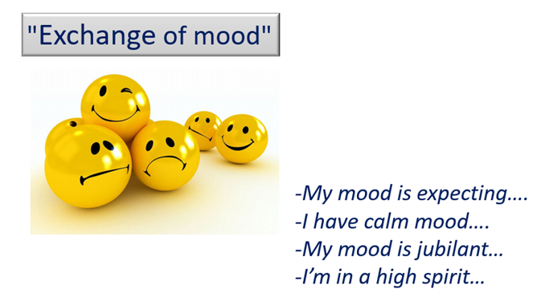

Appendix 2

Video’s screen Shot



Appendix 3

Slide 5

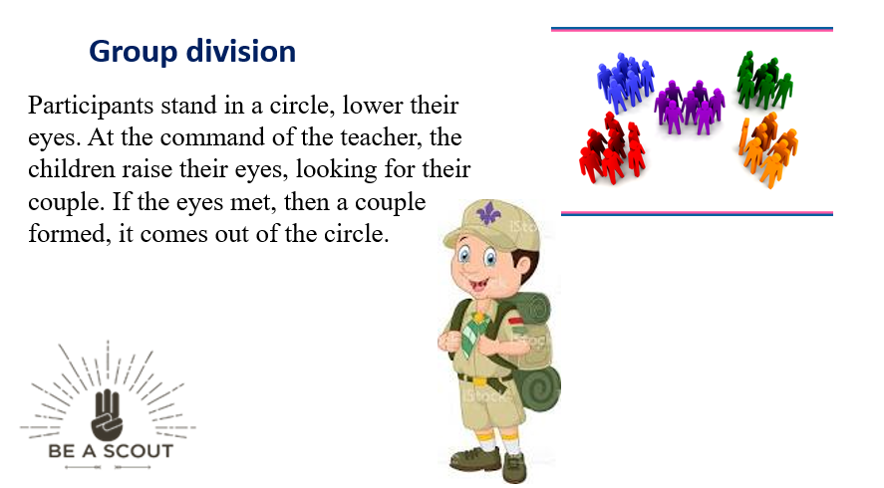

Appendix 4

Slide 6

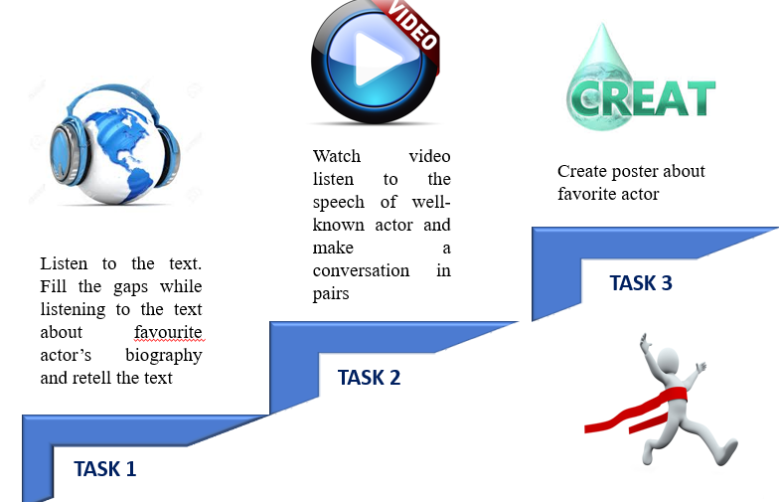

Appendix 5

Slide 7

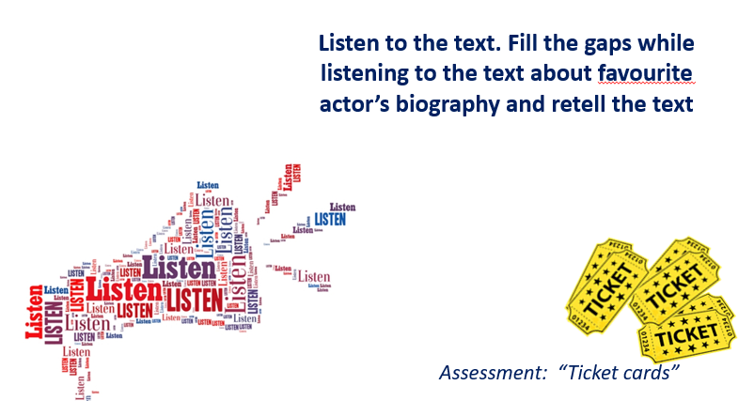

|  |
| --- |
| [Kzyl-Orda](https://en.wikipedia.org/wiki/Kyzylorda), 2011, producer, a police officer, William Shakespeare’s “[Hamlet](https://en.wikipedia.org/wiki/Hamlet)”, 2005, [Prague](https://en.wikipedia.org/wiki/Prague) |

### My favourite actor is Berik Aitzhanov

Berik Aitzhanovis a Kazakh [actor](https://en.wikipedia.org/wiki/Actor) and film **1____________.** He was named Best Actor in **2______________** for his performance in “The Liquidator” and “[Returning to the A](https://en.wikipedia.org/wiki/Returning_to_the_A)”, which hit the [Oscar’s Long List](https://en.wikipedia.org/wiki/Academy_Awards).

Aitzhanov was born in **3**[**___________**](https://en.wikipedia.org/wiki/Kyzylorda), and raised in [Almaty](https://en.wikipedia.org/wiki/Almaty). His father is **4____________** and mother is an educator in kindergarten.

Berik’s career began with theater roles. His debut role was in **5_______________________,** in which he played Laertes the son of Polonius. Berik made his big screen breakthrough in **6_____________**, when he took a part in Rymbek Alpiyev’s “Wolf Hour”. Later in 2005, Berik starred in “Zastava” and “Mahambet” followed by “Mustafa Shokai”, which was filmed in [**7________**](https://en.wikipedia.org/wiki/Prague)**_____**. In 2008 Berik starred in “Brothers”, a TV Series created and directed by Akhan Satayev. Berik continued his run with Akhan in 2010 action-drama film “The Liquidator” co-starring [Vinnie Jones](https://en.wikipedia.org/wiki/Vinnie_Jones) and Karlygash Muhammedzhanova.

**Keys**

1. Producer
2. 2011
3. [Kzyl-Orda](https://en.wikipedia.org/wiki/Kyzylorda)
4. a police officer
5. William Shakespeare’s “[Hamlet](https://en.wikipedia.org/wiki/Hamlet)”
6. 2005
7. [Prague](https://en.wikipedia.org/wiki/Prague)

### My favourite actor is Berik Aitzhanov

Berik Aitzhanovis a Kazakh [actor](https://en.wikipedia.org/wiki/Actor) and film producer. He was named Best Actor in 2011 for his performance in "The Liquidator" and "[Returning to the A](https://en.wikipedia.org/wiki/Returning_to_the_A)", which hit the [Oscar's Long List](https://en.wikipedia.org/wiki/Academy_Awards).Aitzhanov was born in [Kzyl-Orda](https://en.wikipedia.org/wiki/Kyzylorda" \o "Kyzylorda), and raised in [Almaty](https://en.wikipedia.org/wiki/Almaty). His father is a police officer and mother is an educator in kindergarten.

Berik's career began with theater roles. His debut role was in William Shakespeare's "[Hamlet](https://en.wikipedia.org/wiki/Hamlet)", in which he played Laertes the son of Polonius. Berik made his big screen breakthrough in 2005, when he took a part in Rymbek Alpiyev's "Wolf Hour". Later in 2005, Berik starred in "Zastava" and "Mahambet" followed by "Mustafa Shokai", which was filmed in [Prague](https://en.wikipedia.org/wiki/Prague). In 2008 Berik starred in "Brothers", a TV Series created and directed by Akhan Satayev. Berik continued his run with Akhan in 2010 action-drama film "The Liquidator" co-starring [Vinnie Jones](https://en.wikipedia.org/wiki/Vinnie_Jones) and Karlygash Muhammedzhanova.

Appendix 6

Slide 9

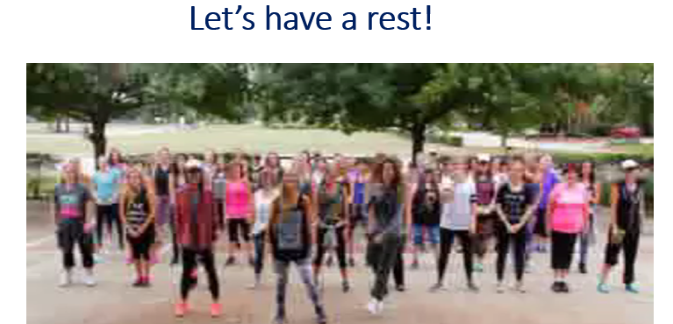

Appendix 7

Slide 10

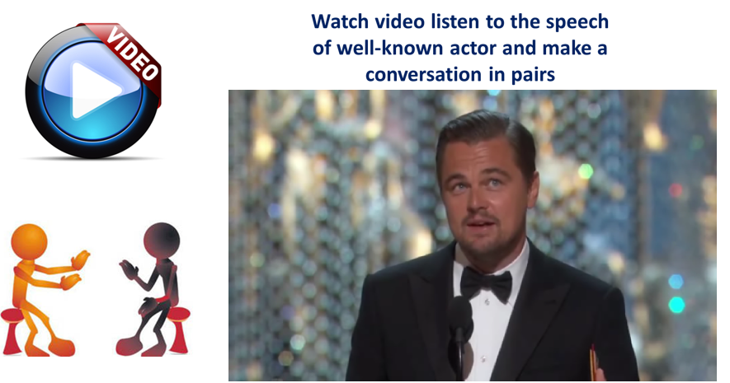

Appendix 8

Slide 11

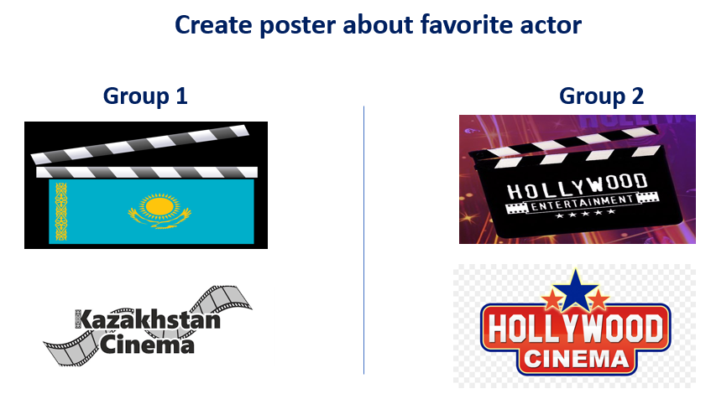

Appendix 9

Slide 12

