Сыныптан тыс жұмыс

Исаева Меруерт Сейдуллақызы
Қызылорда облысы, Шиелі ауданы
№49 орта мектеп

«Біз ағылшын әріптерін білеміз!» атты таңертеңгілігі.

Мақсаты: Оқушылардың ағылшын тілі пәніне деген икем дағдысын анықтау

Teacher: Today we’ll be telling you funny stories. All in English, but at first let’s do one important thing: go over the English alphabet!
Балалар хормен «The Alphabet Song» әнін шырқайды.

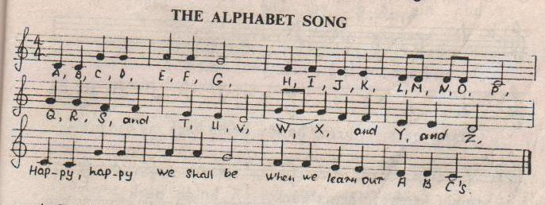
A,B,C,D,E,F,G,H,I,J,K,L,M,N,O,P,Q,R,S,T,U,V,W,X,, and Y, and Z
Happy, happy we shall be
When we learn our ABC’s

Teacher: We know very many letters. How many? Do you know?
Children: Yes!
Teacher: Look at these cards at hers and his. How many?
Children: There are twenty – six.
Teacher: What’s the first one?
Child: Me - the letter «А»
Guess a riddle. What is this? Very red and very sweet. And so very good to eat.
Children: It’s an apple
Child: Right. «A» is for «Apples». They are on a tree. They are for Omar, they are for me.
Teacher: Who’s the second one?
Child: Me – the letter «В». I’ll sing you a little song
It’s about a girl’s friend called Bonnie.
Try to help me if you can!

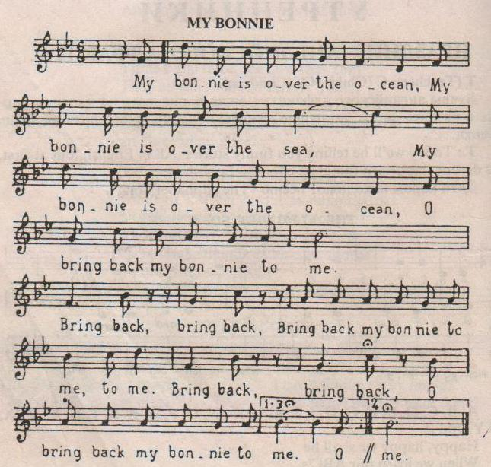

My Bonnie is over the ocean,
My Bonnie is over the sea,
My Bonnie is over the ocean,
My Bonnie, my Bonnie, my Bonnie,
O bring back my Bonnie to me!
Refrain: Bring back, bring back,
Bring back my Bonnie to me, to me,
Bring back, bring back,
O, bring back my Bonnie to me!
Child: Thank you. «B» is for «Ball». We like to play with it. Alma likes the ball, and she runs away with it.
Teacher: Who’s the third one?
Child: Me – the letter «C». I’ll continue the game. «C» is for «Cat». Our cat is grey. It likes to run, and it likes to play. And now guess a riddle: who can say ?
I can tell you all the day.
Time to sleep, time to play
Children: It’s the clock.
Child: You are right again.
Teacher: Who is living in this clock?
Children: It’s a cuckoo-bird.
Teacher: Let us sing a funny song
It’s a cuckoo song.

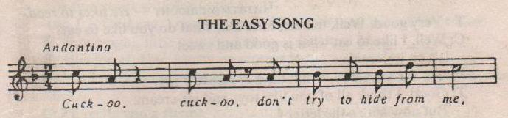
Cuckoo, Cuckoo, don’t try to hide from me,
Cuckoo, Cuckoo, I see you in the tree
Cuckoo, Cuckoo, it’s such an easy song.
Cuckoo, Cuckoo, it’s hard to get it wrong.
«Saw you, saw you,» - I hear the cuckoo say
«Saw you, saw you» - I think, I’m here to stay

Teacher: Who’s the fourth one?
Child: It’s me - the letter «D». I know many words with it. «D» is for «Dog». It is in the street. It likes to run and play with Omar.
Teacher: Thank you, dear! Who’s next?
Child: It’s me – the letter «E». «E» is for «Eight» and for «Eleven», but not for one, two, three or seven. I’ll recite a rhyme about the boy called Evan.
One, two, three, four, five, six, seven
Who help me look for Evan?
He’s not here, he’s not there
I have hunted everywhere
Child: Flowers here, flowers there
Flowers growing everywhere
Teacher: Who are you?
Child: I am the letter «F». «F» is for «Five», and also for «Four». Four little kittens are on the floor.
Teacher: Good! And now, who’s next?
Child: Next is the letter «G», everyone, look at me. «G» is for «Girl». This girl is six. She likes to play with little chicks. And listen please:
This is your garden
And I agree it’s fine.
You love your garden
And I love mine
Child: Now, the letterт «H». «H» is for «Hat». Ann has hat. This is her hat, this but not that.
Teacher: Very good. Well, tell me, little kid, what do you like to eat?
Child: Well, I like to eat what is good and sweet. It’s an ice-cream. I is for I. I am a boy. What have I? I have a toy.
Teacher: Good, I think all of you like toys and ice-cream. But now here’s the letter «J».
Child: «J» is for «Jam». It is on a plate. «Let’s take a little» says little Kate.
Teacher: What else would you like to say?
Child: I want to say,
My jeans are blue,
My pistol’s just a toy,
And I’m such a fine boy,
I look like a cowboy.
Teacher: That’s fine. Now, the letter «K». «K» is for «kettle». And you know that funny song:

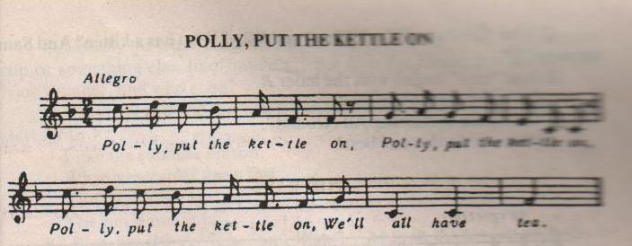

Children: Polly put the kettle on
We’ll all have tea.
Polly, take it off again,
They’ve all gone away.
Child: Look, I see a big yellow lion,
You see a big yellow lion!
What a lion, what a lion!
A lion starts with the letter «L».
And «L» is for «Lena». Lena is nice. She likes cat, and her cat likes mice.
Teacher: That’s right, little one. And now – the letter «M».
Child: «M» is for «Mother». I love my mother very much.
Child: «N» is for «Nelly» and also for «Nick». They are in the garden and where is their chick?
Child: I’ll recite you a rhyme,
Please give me an orange
Because I don’t like to eat
This hot and nasty porridge.
Teacher: You see, «orange» starts with the letter «O»
Child: «P» is for «Pens». Have you a pen? «Yes, I have two» says little Ann. And «puppy» starts with «P».
Puppy, puppy, come to me,
Let us play and that tree
Teacher: And now the letter «Q». Please, read us a rhyme about the quail and yourself
Child: I’ve got a tame quail
My quail has a small tail.
My tame quail has a short beak,
My tame quail is very nice and quick.
«Q» is for Questions: Who? What? and Why? Why has a kitten?
Teacher: And «rain» begins with the letter «R»
Let’s sing a song together!
The rain is raining all around
Who can do this one best?

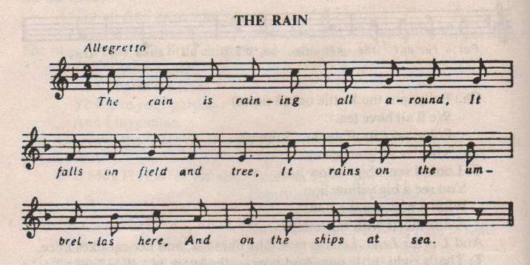
The rain is raining all around
It falls on field and tree.
It rains on the umbrellas here,
And on the ships at sea.
Child: «R» is for «Roses». They are white and red. «Give me this rose, please» says little Fred.
Child: Skate and ski together
On a winter day,
Boys and girls – be happy!
You are so gay!
It was the letter «S», boys and girls. Remember: «S» is for «Sam». Sam has a stick. «Give me your stick», says little Nick.
Teacher: What’s next? Who knows?
Child: I know. It’s the letter «T».
The words like toys, toothbrush and tram,
My teacher, my teacher and tree-
Are good and interesting for me!
«T» is for «Tom». Tom takes a tram. He takes a tram, and he goes to Sam.
Child: Usually the letter «U» is found in the middle. Of words cube, bus and cup or something else, like muddle. But «U» is for «Under», but not for On, Nick is under, who is on?
Child: «V» is in «Five» and also in «Seven», it’s in «Twelve», and in «Eleven». «Vegetables» - starts with «V».
I like the summer season,
When vegetables grow fast
And here is the reason:
The sun is out at last.
Teacher: «W» is for «Where?» «Who?» and «What?». Who is the garden and who is not?
Child: My watch is running night and day,
But it will never run away.
Watch begins with «W»
Child: I have a very good crayon box
And very many crayons.
I draw a taxi and a fox
In bright green, red and yellow.
Teacher: That was a letter «X». Remember: «X» you can see in «Box» and in «Six.» But not in books or looks, or chicks. And here is «Y».
Child: «Y» is a «Yard» for puppies to play. They like to play on a summer day. And also In winter you and me
All children like to ski
In the evening you and me,
We like to have hot tea
We like as well to look at the
New Year tree
And sing: «The More We Are Together
The merrier we’ll be!»
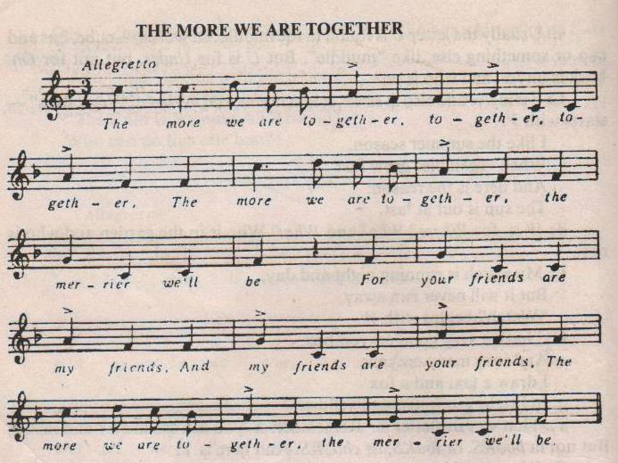
The more we are together, together, together
The more we are together, the merrier we’ll be
For your friends are my friends
And my friends are your friends,
The more we are together, the merrier we’ll be!
Teacher: The last letter is the letter «Z».
Child: «Z» is for «Zebra». It lives in the Zoo.
Teacher: Very good! Now please, answer my question: «Рахмет» cөзінің ағылшынша аудармасы қалай болады?
Children: Қысқа екі сөзден тұратын «Thank you»
Teacher: Right you are. Thank you for your good knowledge of English. We’ve just gone through the English Alphabet. Let’s sing «The Alphabet Song» together again.

