Lesson plan

Unit 3. Our world. Time for CLIL. |  | School: 54
Date: |  | Teacher name: Kakhmetova Feruza
Grade: 3 V |  | Number present:13 | absent:

Theme of the lesson: Unit revision3. “Time for CLIL”
Lesson objectives |  | All learners will be able to:
- Consolidate pupils’ knowledge on the theme days, numbers, times
- To develop skills and habits of speaking, listen, reading and writing
- To teach using time correctly
Cross - curricular links |  | Lesson is connected Maths
Plan
Planned timings | Planned activities |  |  | Resources
Beginning  (2 mins)  (2 mins) | Organization moment:  -Good afternoon pupils  -Who is on duty today? – I’m on duty today  - Who is absent? – all are present  - What date is it today? – it is twenty seventh  - What day is it today? - it is Tuesday  Psychological condition  - So pupils today is special lesson. We have guests. I wish you “Good luck”  - Pupils: all together “Good luck teacher”  Checking homework  -What was your homework? – It was to learn numbers  - I will throw the ball saying the word in Kazakh and you say me in English 10, 20, 30, 40, 50, 60, 70, 80, 90, 100 |  |  | Checking home work throwing the ball “Ball”
Beginning  (2 mins)  (2 mins) | Telling the lesson objectives  So pupils, today we consolidate materials on the themes days, numbers and times.  To develop skills and habits of speaking, listening, reading and writing  To teach using time correctly  We will do group, individual works, test and others
 | Dividing pupils into two groups  1 group – Time  2 group - Days |  |  | Dividing pupils into two group
Middle  Writing  (3 min)  Writing  Speaking  (5 min)  Listening  Speaking  Writing  (2 min)  Poster-№2  (7 min)  (2 min)  Listening  (3 min)  Reading  (6 mins)  Writing  (3 mins)  Conclusion  (3 min) | Practice  - Vocabulary words  Let’s remember vocabulary words  - Talk about the picture  Let’s do exercise. Talk about the picture.  “A day of my family”. Please complete the sentence.  - Lost letters  Mdaoyn –  Tsuadye –  Wyendedsa –  Tshaudry –  Fdraiy –  Stareduy -  aSnyud -  - Work with text “ Alex’s week”  Pupils look at the board. Listen the text 3 times.  Ok,  The week group -answer the question.  The time group-complete the sentence  Work with the words from the text.  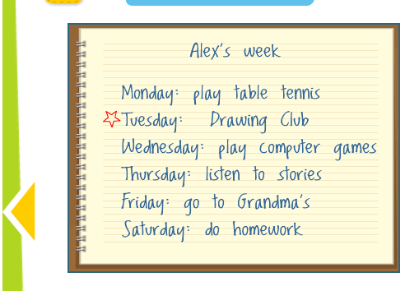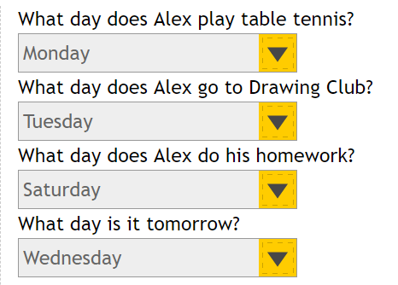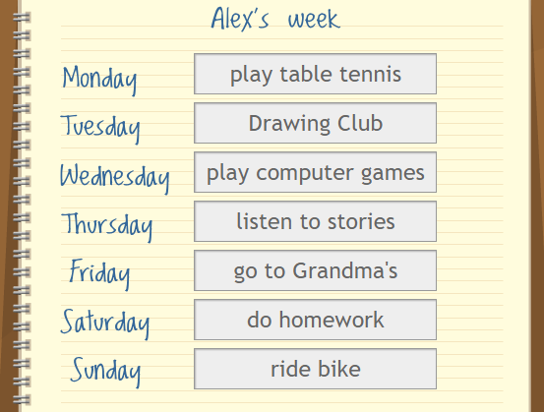  - Warm up  Pupils, are you tired? Let’s relax. Stand up please.  - Say the time  - What time is it? – It’s 1 o’clock etc.  1,2,3,4,5,6,7,8,9,10,11,12  - Work with the text ( Ex 28 page 46)  Pupils, let’s read the text.  1 text – Teatime in UK  2 text – Teatime in Kazakhstan  - Pair work. (Ex 29, page 46)  Teatime in UK  - Five  - Sugar  - Sandwiches  Teatime in Kazakhstan  - Black tea  - Milk  - Kesse  - I know …  Days of the week  Numbers I know … What time is it? |  |  | Get up, go to school, have breakfast, have lunch, have dinner, watch TV, have a shower, read, brush the teeth, sleep.  Group work  DIDACTIC MATERIAL 1  Individual work  Monday, Tuesday, Wednesday, Thursday, Friday, Saturday, Sunday  Group work  Doing physical training by video  To say the time by the video  Work with the text  Pair work  Days,  Times,  Numbers.
End  2 mins | Feedback: Giving marks (excellent, good, satisfactory )  Reflection  Learners reflect on their learning:  - I didn’t understand everything  - I understood but not very well  - I understood everything

