Lesson plan
Unit 4 : Drama and comedy |  |  | School:
Date: |  |  | Teacher name:
CLASS: 6 |  |  | Number present: |  | absent:
Lesson title |  | My country. Kazakh films
Learning objectives |  | 6.1.6.1. Organise and present information clearly to others;  6.3.2.1. Ask simple questions to get information about a limited range of general topics;  6.3.4.1. Respond with limited flexibility at sentence level to unexpected comments on an increasing range of general and curricular topics;  6.4.2.1 understand independently specific information and detail in short, simple texts on a limited range of general curricular topics.
Lesson objectives |  | All learners able to:  - identify information about Kazakh films and actor Asanaly Ashimov;  - define true or false sentences in the text;  - recognize typical features at word.  Most learners able to:  - answer the questions on a topic;  - build links between events (actor's biography) in the text.  Some learners able to:  - compose questions and make up a dialogue;  - create a poster and speak about Kazakh actor using topic vocabulary.
Assessment criteria |  | - identify detailed information in the text;  - demonstrate ability to organise and express ideas clearly to others;  - make up questions and answers to get some more information about Kazakh films and actor.
Values links |  | Respect for self and others, Co-operation
Cross-curricular links |  | Films and cinematography
Previous learning |  | Writing about a life of a famous person.
Plan
Planned timings | Planned activities (replace the notes below with your planned activities) |  |  |  |  |  | Resources
Start  4 min | Organizational moment.  Teacher divides learners into two groups. Learners choose the sheets of papers and find their seats (the names of the groups are Films and Actors)  (G) Warm up:  Learners write "Cinquain" using words actor and star.  1.Theme (1noun)  2. Description of the topic (2 adjectives)  3. Action (3 verbs)  4. 1 sentence  5. 1 Synonym to the theme |  |  |  |  |  | Sheets and cards  Handout1
Middle  4 min.  5 min.  5 min.  7 min.  2 min  10 min. | (W) Pre reading: Focus on vocabulary.  "Steps" learner reads the words on the steps and give Russian or Kazakh equivalents of this words.  FA: by Choral Response. Teacher observes the learner's answer.  Reading  (W) Teacher asks learners to read the story about “Asanaly Ashimov”.  Post-reading  Activity 1  (I) After reading the text learners identify true or false and correct the false sentences.  FA: by self-assessment teacher shows the answers on the slide and learners check themselves.  Activity 2  (G)Learners build links between actor's biography and  make a poster using graphic organizer 'Sequence Chart'.  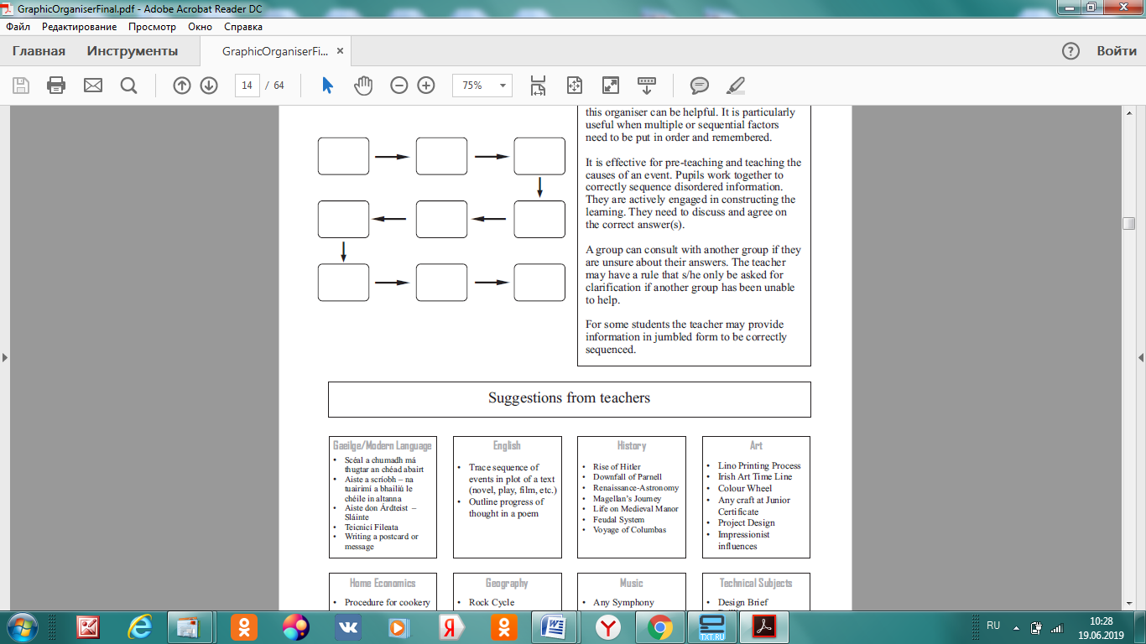  FA: by checklist (two groups evaluate each other, if they like it they get a star)  Mentioned all moment of author's life Language is clear Everyone speaks  Group 1  Group 2  In total: the group that has 3 stars, will receive medals  Physical activity  Speaking  Activity 3  "Author and you" strategy.  Learners works in pairs, compose open and closed questions according on a topic and make up a dialogue.  Descriptor: a learner  -works with a partner ;  - make up open and closed questions;  - acts a dialogue.  Differentiation:  Less able learners make up closed questions and write a dialogue of scene from the story about Asanaly Ashimov.  More able learners make up open-ended questions and write a dialogue according to their own actor.  Peer-assessment: "Teach a friend"  Criteria: Yes No  All the questions are answered  Language is clear  Identify the following questions |  |  |  |  |  | PPT slide1  English Plus Student's book Grade 6  Oxford University press Ben Wetz, Diana Pye  p.52  PPT slide 2  Graphic organizer "Sequence Charts"  Sheets of paper  Assessment sheets  https://www.youtube.com/watch?v=VtEcBIn8kRo  Аssessment sheet
End  3 min | (W) Reflection  Learning Logs  The teacher hangs a poster on the Board with a picture of the instagram page and asks students to leave a comment about the topic. (what they have learned, understand, don't understand during the lesson) |  |  |  |  |  | PPP slide 3
Additional information
Differentiation – how do you plan to give more support? How do you plan to challenge the more able learners? |  |  |  | Assessment – how are you planning to check learners’ learning? |  | Health and safety check
By outcome  Less able learners make up closed questions and write a dialogue of scene.  More able learners make up open-ended questions and write a dialogue according to their own actor. |  |  |  | by "Choral Response",  by self-assessment,  by "Checklist",  by "Teach friend". |  | Art,  Physical exercise

