Lesson Plan

LESSON: Communication around the world  Types of transports/  Транспорт түрлері |  |  |  |  | School: №14
Date:10.12.2019 |  |  |  |  | Teacher name: Zhapsarbaeva Maral
CLASS: 4 D |  |  |  |  | Number present: |  | absent:
Learning objectives(s) that this lesson is contributing to |  |  |  | 4.1.3.1 understand the main points of short supported talk on an increasing range of general and curricular topics  4.2.1.1 make a basic statements which provide information on an increasing range of general and some curricular topics
Lesson objectives |  |  |  | - to introduce new words about transports  - understand the main thought of the text and give their own opinion with little support  - to complete and write accuracy the words
Assessment criteria |  |  |  | To talk about and compare means of transports
Value links |  |  |  | Respect to others, collaboration, academic honesty
Cross curricular lin lin |  |  |  | Geography
ICT skills |  |  |  | Projector or Smart board for presenting videos, PPT.
Intercultural awareness |  |  |  | Students will be able to understand that every person should respect the values of other countries..
Target vocabulary |  |  |  | Means of transports: tram ,underground, helicopter ,plane, scooter – скутер,  ship, bus ,car, motorbike
Pastoral Care |  |  |  | Taking into account needs of all learners
Health and Safety |  |  |  | Everyday classroom precautions will ensure that safety measures are provided to prevent the exposure of electrical power cords
Previous learning |  |  |  | Learners learned the vocabulary to the topic ‘Body language’
Plan
Beginning  0-2 minutes  2-4 min  4-6 min  6-8 min | Organization moment/Aмандасу  Teacher greets learners; learners respond to greeting and take their places.  Мұғалім оқушылармен амандасады, оқушылар да амандасып өз орындарына жайғасады.  II.Brainstorming/Миға шабуыл  Revision the previous lesson. Scrambled letters. You must make up some words and translate them into Kazakh.  III. Pre-learning/ алдын ала оқыту  Now, look at the our magic box. So guys let`s guess what is there and what about the theme of our lesson.  Балалар біздің сиқырлы қорабымызға қараңыздаршы.Қазір біз сіздермен оның ішінде не бар екенін тауып бүгінгі сабағымыздың тақырыбын ашамыз. Strategy « In my opinion »/ « Менің ойым стратегиясы»  In my opinion –  I think –  Introduce the topic and the objectives of the lesson to students./ Сабақ тақырыбымен және сабақ мақсатымен оқушыларды таныстыру.  - to introduce new words about transports  - транспорт тақырыбында жаңа сөздермен танысып,біледі  - understand the main thought of the text and give their own opinion with little support  - мәтіннің негізгі ойды тауып,мұғалімнің көмегі арқылы өз ойларын жеткізеді  - to complete and write accuracy the words  - сөзді толық және қатесіз жазады |  |  |  |  |  | PPT slide 1  PPT slide 2  Magic box  PPT slide 3,4  PPT slide 5,6  PPT slide7
8-13 min  13-15 min  15-25min  25-28min | IV. New words strategy/ Жаңа сөз стратегиясы  And so guys, let`s write then repeat new words about types of transport сhorally and individually /Сонымен балалар бүгінгі тақырыбымызға байланысты жаңа сөздерді жазып, ,барлығымыз және жекелеп қайталайық.  tram – трамвай  underground - метро  helicopter – тікұшақ  plane –ұшақ  scooter – скутер  ship- кеме  bus – автобус  car- машина  motorbike – мотоцикл  fast – жылдам  slow – баяу  safe – қауіпсіз  dangerous – қауіпті  quite – тыныш  noisy – шулы  cheap – арзан  expensive - қымбат  FA/ҚБ Fine! Well done! Excellent  Жарайсың!Бәрекелді! Керемет!  - So guys, what do you think we are achieved the first aim?  - Балалар қалай ойлайсыздар 1 – ші мақсатымызға жеттік пе?  V. Warm – up. Сергіту сәті  Sing song ``Zoom, zoom my plane``  VI. Boys and girls come to me and let`s choose one of the picture, after divide into 3 groups.  Балалар менің қасыма келіп суреттердің біреусін таңдап , сол сурет бойынша 3 топқа бөлінеміз.  1 group - Land 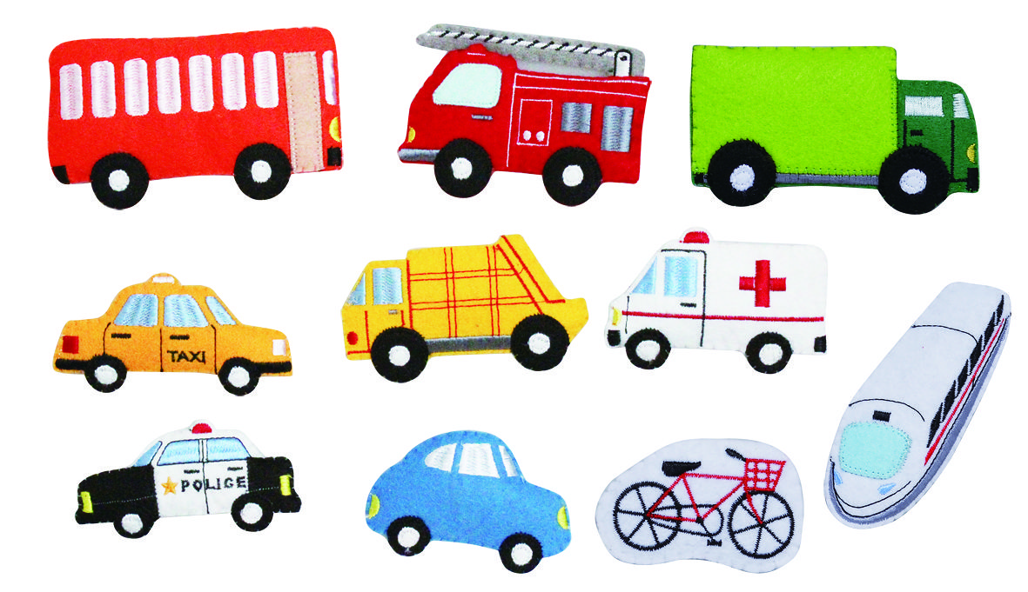  2 group - Air 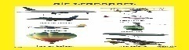  3 group - Sea. 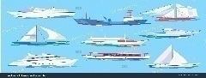  VII. (G) Group work  So, guys our next task is group work, I`ll give you three texts about Land, Air and Sea transports.  Сонымен балалар, біздің келесі тапсырмамыз топтық жұмыс.Мен сіздерге көліктерге байланысты үш мәтін беремін.  Land Transport  The most popular means of transport is a car. Nowadays there are so many car producers and brands that a car becomes the most popular and comfortable type of transport. You can travel by car everywhere. The only thing that can stop you is your driving license and the foreign country rules. А dream of many people is to buy a car and for most of them it comes true.  Air transport  Planе is popular for its speed but the cost is quite high. It is thought to be the safest means of transport among all. It is the fast speed means of transport. Passengers and goods can be transported easily from one place to the other. Air transport is a costly service. Its operational costs are too high. Middle class and poor people can not affect its cash.  Sea transport  The most luxurious means of transport is a ship. I mean not those small ordinary ships, but the ones that travel across the oceans with thousands of tourists. They are often called liners. The transport channel is quite cheap as compared rail and road Transport. It is a slow means of transport. Water transport is more risky as compared to other means because there is always danger of sinking ships or boats.  Descriptor  - read the text with the correct pronunciation  - мәтінді дұрыс оқу  - can describe the main thought of the text  - мәтіндегі негізгі ойды сипаттайды  - makes up short sentences with support adjectives words  - тірек сын есімдерді қолданып, қысқаша сөйлем құру  Presumptive answers:  A: explain correctly its opinion about the text  B: presumptively replies on the text  C: answers only the questions asked in the text  - So guys, what do you think we are achieved the second aim?  After you should evaluate the group work by descriptor.  Содан соң бір топ екінші топты дескритор арқылы бағалaйсыздар.  VIII. Pair work. Жұптық жұмыс  Find the means of transports. Көлік құралдарын табу  Descriptor  - can find the things appropriate for transports  - көлік құралдарына сәйкес заттарды таба алады. |  |  |  |  |  | PPT slide 8,9  Handout 1  PPT slide 10  PPT slide 11  Handout 2
28-30min  30-32 min  32 – 35 min  35 – 40 min | - Come back to the lesson objectives and summarize with students if they met the lesson objectives. Ask them to give the weather feedback.  - So guys, if everything is clear to you, we show sunny weather, but if you have questions cloudy weather.  Reflection.Рефлексия « Sunny day and cloudy day »  « Ашық күн мен бұлтты күн »  - What did you learn from today`s lesson?  2 . What new words and adjectives do you remember?  Song: Bright blue the sky  Thanks for your attention!  The lesson is over good bye!
Additional information
Differentiation – how do you plan to give more support? How do you plan to  challenge the more able learners? |  |  | Assessment – how are you planning to check learners’ learning? |  |  | Cross-curricular links  Health and safety check  ICT links  Values links
Reflection  Were the lesson objectives/learning objectives realistic?  What did the learners learn today?  What was the learning atmosphere like?  Did my planned differentiation work well?  Did I stick to timings? What changes did I make from my plan and why? |  | Use the space below to reflect on your lesson. Answer the most relevant questions from the box on the left about your lesson.
Summary evaluation

What two things went really well (consider both teaching and learning)?

1:

2:

What two things would have improved the lesson (consider both teaching and learning)?

1:

2:

What have I learned from this lesson about the class or individuals that will inform my next lesson?

