Long-term plan: Unit 5: Travel |  |  |  | School: №62 гимназия
Date: |  |  |  | Teacher name: Begimbetova G
Grade: 1 А |  |  |  | Number present: 15 |  |  | absent:0
Theme of the lesson |  |  |  | Where is it? It is under the table
Learning objectives(s) that this lesson is contributing to |  | 1.UE11 use there is/are to make short statements  1.S1 make basic personal statements and simple statements about objects  1.L2 recognise with considerable support a few basic personal questions spoken slowly and distinctly
Lesson objectives |  | All learners will be able to:
Make sentences using there is/are and house vocabulary with support from the teacher
Ask and answer questions about pictures
Most learners will be able to:
Make sentences using there is/are and house vocabulary with some errors
Ask and answer questions about pictures
Some learners will be able to:
Make sentences using there is/are and house vocabulary with no support
Ask and answer questions about pictures
Success criteria |  | Learners have met this learning objective if they can  -understand & recognise 6-8 objects and name them correctly;  - understand & recognise is there / are there questions;  - pronounce all the words correctly.
Value links |  | Family values
Cross curricular links |  | All the subjects they have because they study the same topics there
ICT skills |  | PPT – by the teacher
Previous learning |  | There is/are +furniture and prepositions
Plan
Planned timings | Planned activities (replace the notes below with your planned activities) |  |  |  |  | Resources
5 minutes  5 минут | The lesson begins with the game “route”the main freezing-to make sure that the letters of the word being pondered are the previous letter.  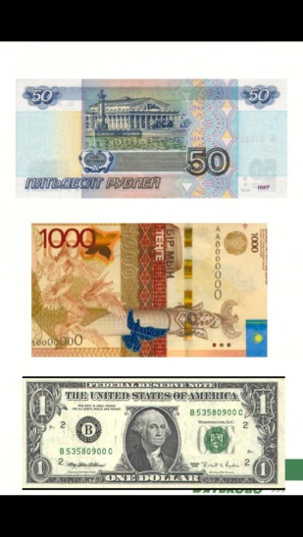  The beginning of the lesson begins with a passport, children solve the problem and get a passport visa to London. |  |  |  |  | Students’ cards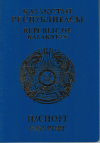
Middle  5 mins  7 mins  7 mins  3 mins  10 mins | 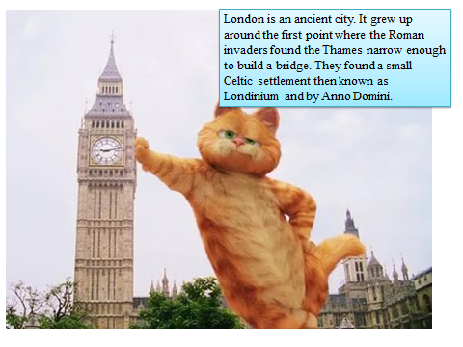  After chills with London, children have a dialogue with a friend  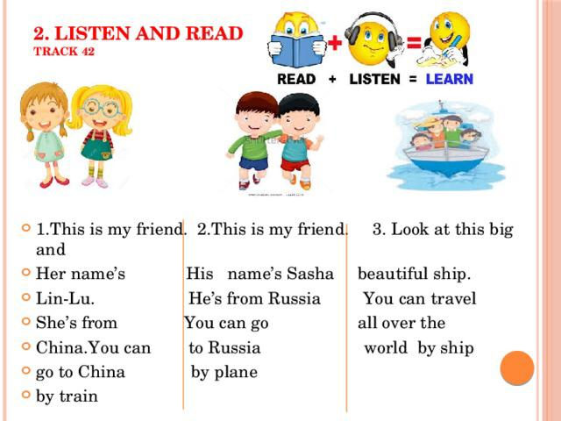  Аfter London, children take the train to Italy.  Teacher demonstrates and drills basic prepositions.of place: in, on, under, next to, in front of, behind using visuals at board.  IN, ON, UNDER  Practice work  - Work with the cards.  - Prepositions of Place Handwriting Worksheet. Trace the prepositions and then draw a line to the correct picture.  - Prepositions – in, on,under. Fill the blanks and then drawa line to the picture.  REVISION  Learners take toy car and follow the teacher’s instructions:  Car is in the box  Car is on the box.  Physical training.  Students and teachers act to present the prepositions in front of the board. Show me ON (students pretend to stand on something), IN (they hug themselves), UNDER (they hold their hands above the head).  Inner/outer circle (FA)  Ss make two circles one inside and one outside. Inside circle hold pictures and ask questions. Outside circle should answer and tern to next one. Teachers monitor, support students |  |  |  |  | Ppt
End  5 min | Go back to what your objectives were and ask students if they achieved them. Teacher praises stickers to the students who was able to make correct sentences.  Home task: learn the words (in my house)
Additional information
Differentiation – how do you plan to give more support? How do you plan to challenge the more able learners  the will be |  |  | Assessment – how are you planning to check learners’ learning? |  | Health and safety check  ICT links
- Weaker Ss work with T’s support  - Stronger Ss work on their own |  |  | - When T asks questions and act out prepositions |  | Learners will be safely arranged and seated in front of the monitor away from electrical outlets and cables.
Reflection  Were the lesson objectives/learning objectives realistic? Did all learners achieve the LO?  If not, why?  Did my planned differentiation work well?  Did I stick to timings?  What changes did I make from my plan and why? |  |  | Use the space below to reflect on your lesson. Answer the most relevant questions from the box on the left about your lesson.
Summary evaluation

What two things went really well (consider both teaching and learning)?
1:teaching using visuals because it helped children to remember the sentences

2: revision using cards and a stimulation system

What two things would have improved the lesson (consider both teaching and learning)?
1: FA next time should be retaken with most of the students as they couldn’t understand the procedure so failed the task.

2:having a support from another teacher was very effective

What have I learned from this lesson about the class or achievements/difficulties of individuals that will inform my next lesson?

Ramazan needs more attention and support
Zakhar should be pushed to do more difficult things

Next time we will plan less activities but the process of them will be more sufficient

