**The theme of the lesson:** *“TREASURE HUNTING”*

**Date:** 28.11.2019

**Teachers:**Salikova A.O. Nukisheva Zh.K **Quest Goal:** Improving the forms and methods of extracurricular and extracurricular activities for studying English by students through their involvement in an entertaining interactive action; developing interest in learning English.

**Quest Objectives:**

• draw the attention of the younger generation to the monuments of architecture and cultural objects of the United Kingdom;

• familiarize with country-specific information;

• develop a sense of ownership in solving tasks;

• help learn new useful information;

• create conditions for unlocking the creative potential of participants;

• create conditions for self-realization of students;

• encourage students to further study the history and geography of Great Britain, its cultural and linguistic features, instill in them respect for history, cultural and historical monuments.

**Rules for the game-quest "TREASURE HUNTING":**

The quest game "Treasure Hunting" is a series of tasks that are consistently performed by all teams. According to the route laid on the map, the team goes through all the stations in turn.

A variety of contests and quizzes are waiting for children at 6 stations, and at the end - a Super game, during which you will have to guess about the place where the "sweet prize" is hidden. Each team for a certain time must complete a series of tasks and achieve a result - to collect the maximum possible number of "gold doubloons" and the minimum number of "black marks". For correct answers, the team receives a “gold doubloon”, and for incorrect answers, the team receives a “black mark”. Passing each stage makes it possible to proceed to the next stage.

**Quest participants:**

2 teams of 6 - 7 players each. The names of the teams given in accordance with the pirates

Quest organizers: English teachers.

Location of the quest: training classes, library

**Equipment:**

• Maps with an individual route indicated on them (by number teams);

• Observer rating sheets (by the number of teams);

• Props at stations;

• Tasks for each station;

• Certificates to winners and participants;

• Prizes for rewarding.

**Preparatory work:**

• prepare tasks for each stage, taking into account the level of training teams;

• prepare special clothing for sailors, soldiers and pirates

• identify cabinets for stations;

• instruct station observers;

• attach plates to the door;

**Evaluation Criteria and Summary:**

According to the results of the quest, the winner is determined. Team members who won prizes are awarded with certificates of winners; other teams are awarded with certificates of participants. All participants receive

"Sweet" prizes.

**Plan**

1. ***Jack Vorobei’ s monologue***

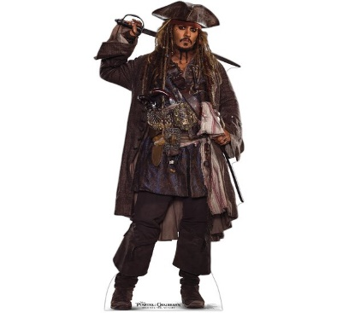

Hello! My name is Jack Vorobey. The school has a treasure hidden. I divide your into two groups. At each station, children pass tests. For the correct answers at each station, the team receives a “gold doubloon”, for the wrong answer - a “black mark”. Who has more gold doubloons and find treasure the winner. The location of the treasure is indicated on the map.

1. ***«Ocean of Numbers». Solve problems and collect the answers.***

420+150 Five hundred and seventy

180 +230 Four hundred

700-360 Three hundred and forty

980-620 Three hundred and sixty

870+130 Thousand

1. ***Curiosity Land. Assemble the pirate journey puzzle.***

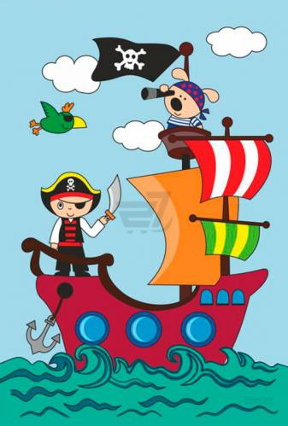

1. ***«The pirates’ treasure» watch video. Match the true or false.***

The find gold fish in the river

There was sand in the bottle

The parrot can’t see the volcano

There is a cave between the volcano and the trees

The treasure is in the cave

There were jewels and gold in the chest

1. ***Listening “Treasure map”***

Sanjay saw a bottle floating in the sea. There was something inside it.

He took it out.

‘What is it?’ asked Sarah.

‘It’s a map! It’s a map!’

They looked round and saw a talking parrot.

‘Buried treasure! Buried treasure!’

‘Wow! A treasure map! Let’s follow it.’

‘Maybe it’s gold!’

‘Or silver?’

‘Or jewels?’

‘OK. We are here and the treasure is here.’

‘Let’s go! I’ll read,’ said the parrot.

‘Walk 80 metres north.’

‘1, 2, 3 … 78, 79, 80.’

‘Turn right at the big coconut tree and go straight on until the crocodile pond. Cross the bridge, turn left and keep walking. Turn right in front of the big, round rock. Walk straight ahead for 50 metres.’

‘1, 2, 3 … 48, 49, 50.’

‘Go through the cave. Mind the bats! Mind the bats! Walk straight on until the beach. Go along the beach for 200 metres. The treasure is behind the square rock.

‘Over there! Over there!’ Parrot shouted.

‘It’s empty!’ cried Sarah. Inside there was an old note.

Dear Finder,

Sorry, but I took my gold. I needed to buy a new pirate ship.

Bye,

Captain Redbeard.

‘Well, at least we had a nice walk,’ said Sanjay.

‘Yes, and we made a new friend!’

1. ***Make up a treasure map.***

**Conclusion:** The observer counts the gold doubloons of each team. Reveals the winner and presents the treasure.