Нахыпбек Мәдина Мейірбекқызы
Түркістан облысы Ордабасы ауданы “Ынтымақ” жалпы орта мектебі

Unit of a long term plan Unit 7 Music and films |  |  | School: Intimak
Date: 5.03.2020 |  |  | Teacher’s name: Nakhypbek M M
Class: 9 А,Ә,Б |  |  | Number present: |  | Number absent:
Lesson title |  |  | My Country. Music and film. p.88CLIL.Culture: Britain in the 1960s. p.89
Learning objectives(s) that this lesson is contributing to |  | 9.R5 deduce meaning from context in extended texts on a wide range of familiar general and curricular topics, and some unfamiliar topics  9.R6 recognise the attitude or opinion of the writer in extended texts on a wide range of familiar general and curricular topics  9.R7 recognise typical features at word, sentence and text level in a wide range of written genres, including some which focus on unfamiliar topics
Lesson objectives |  | All learners will be able to:  Identify the meaning of the text about a famous Kazakh actor and Britain in the 1960s, recall facts and basic concepts.  Most learners will be able to:  Select, compile, and synthesize information for an oral presentation  Provide a point of view in conversations and discussions;  Synthesize information from the reading passagesfor a discussion.  Some learners will be able to:  Respond to and discuss the reading passage using interpretive, evaluative and creative thinking skills.  Discuss and give their opinions about an alternative lifestyle using own words.
Value links |  | Cooperation, respect each other's opinion, functional literacy, Responsibility, Global Citizenship, Respect and Love to people.
Crosscurricular links |  | Social Science, Art, History, Psychology, Literature, Geography,Information Technology.
Previous learning |  | Talking about shopping and problems with bought products.
Useof ICT |  | Smart board for showing a presentation, getting additional information,playing the audio files.
Intercultural awareness |  | The life of people nowadays and in the 1960s.
Health and Safety |  | Breaks and physical activities used. Everyday classroom precautions will ensure that safety measures are provided to prevent the exposure of electrical power cords.
Planned timings | Planned activities |  |  |  |  |  | Resources
Beginning of the lesson  7 min. | The lesson greeting.  The teacher sets the lesson objectives, letting students know what to anticipate from the lesson.  Then to create a positive learning environment the teachers asks students to start the lesson.  Warm up.Free talk about the life of Chingiz Kapin and Britain in the 1960s.A teacher suggests listening the lines from the song” Yesterday|” by the group Beatles and an episode with Chingiz Kapin from the film.  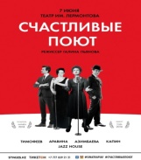   |  |  |  |  |  | Slide (useful phrases).  Pictures  PPT  Student Book p.88  the song” Yesterday|”  Writing  Worksheet
Main  Activities  15 min.  12 min. | Main part  Pre - reading task: introduction of new words: Ex.1  Ex.2 p.88. Listen and read the text.  Ex.3 - 4 p.88 for comprehension of the text.  Name the films with this actor in the leading part.    (A film”Zaure).  Look at the photos of Ex.1 and speak about this period in the life of people in Britain. Answer the questions.  The 1960s overturned the country’s old order and brought in the new, as the economic boom reverberated: governments fell through scandal; spies were exposed in the heart of the establishment; England won the World Cup; the arts, fashion and entertainment industries burst with new ideas and young people dominated events.  The students in pairs write down some facts about the life in 1960s.  Britain in 1960s Kazakhstan in 1960s  During the 1950s and 1960s, Soviet citizens were urged to settle in the Virgin Lands of the Kazakh Soviet Socialist Republic.  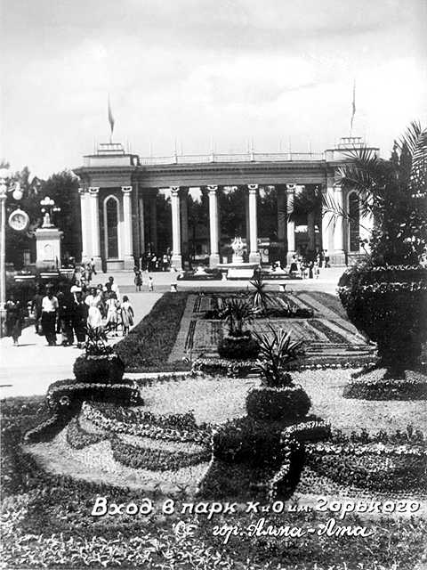  Ex.3 – 5 p.89.  Make a short presentation of Alma-Ata in sixties. |  |  |  |  |  | Student Book p.89  CD. 3.08  (PROJECT O R D I N A R Y F A M I L Y (CHINGIZ KAPIN)  Pictures  PPT  Student Book p.88  CD.3.09  A Table  Writing  Worksheet
Ending the lesson 6 min. | Giving the home task.  W.B. p.58, Ex.5 p.89 St. B. (group work).
Differentiation –  how do you plan to give more support? How do you plan to challenge the more  able learners? |  |  |  | Assessment –  how are you planning to check learners’ learning? |  | Critical thinking
Differentiation can be achieved through the selection of activities, identification of learning outcomes for a certain student, provision of individual support to learners, selection of learning materials and resources based on the individual abilities of learners. |  |  |  | Assessment criteria:  Identify the main idea in extended talks with little support.  Apply topic related vocabulary in speech appropriately arranging words and phrases into well-formed sentences.  Demonstrate the ability to participate in a conversation. |  | Students think critically, exploring, developing, evaluating and making choices about their own and others’ ideas

