LESSON PLAN
Long-term plan unit: Charities and Conflict |  |  |  | School: Khromtau Secondary School №4
Class: 9 |  |  |  | Teacher name: DiyarovaAssemAlibekovna
Date: 24.05.2019
Theme of the lesson: Social problems |  |  |  | Number present |  | absent:
Learning objectives(s) that this lesson is contributing to |  | 9.4.1.1 understand the main points in extended texts on a range of unfamiliar general and curricular topics.  9.3.1.1 use formal and informal registers in their talk on a range of general and curricular topics.  9.5.3.1 write with moderate grammatical accuracy on a wide range of familiar general and curricular topics.
Lesson objectives |  | All learners will be able to:  - Understand the main points of the given text  - Use formal and informal registers in their talk with support  - Write6-7 sentences with moderate grammar accuracy on topic
Most learners will be able to:
- Understand the given text in details
- Use formal and informal registers in their dialogue
- Write a 8-9 sentenceswith moderate grammar accuracy on topic
Some learners will be able to:
- Give opinion use formal and informal registers without support
- Write essay about social problems
Previous learning
Plan
Planned timings | Planned activities (replace the notes below with your planned activities) |  |  |  |  | Resources
Start | (W) Organizational moment  Teacher greets learners; learners respond to greeting and take their places.  - Good morning! How are you?
3 min | Warm-up activity:  HOLIDAY activities  HOLIDAY activities  (W) Activity. The learners are confronting each other and applaud their hands and say: «Double This Double That …»  Dividing the class into three groups using colored stickers. |  |  |  |  | https://www.youtube.com/watch?v=g4ea2GmBq  colored stickers,
Middle  5min | Pre-reading  (W)“Look, think, discuss” method. The teacher before reading the text shows the picturesand asks questions: what do you see in this pictures? how do you think, what about we talking in our lesson?  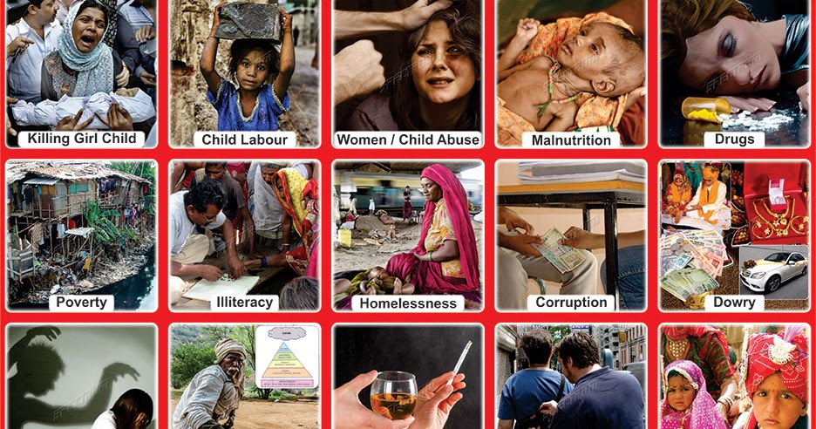  •Teacher presents the lesson objectives on the active board:  Today you will:  - Talk about the social problems;  - Learn new words;  - Do the different tasks according to the theme;  - Defend your opinion;  - Discuss and give feedback to each other.  (W)«Association» method.  Teacher asks students to give association to the phrase “Social problems”  Social problems |  |  |  |  | Pictures  https://spectrumchart. blogspot.  com/2017/02/chart-635-social-  problems-in-india.html
3 min  5 min  5 min  6 min  10 min | “Social Problems”  Social problems are the general factors that affect and damage society. A social problem is normally a term used to describe problems with a particular area or group of people in the world. Social problems often involve problems that affect the real world. It also affects how people react to certain situations. Examples can include: anti social behavior, poverty, drug abuse, transgenderism, prostitution, alcohol abuse, economic Deprivation, unemployment, sexual abuse, rape, early pregnancy, female genital mutilation, animal abuse, the shortage of schools the lack of infrastructure.  Marlow is officially the most deprived and worst place of living in the United Kingdom due to its social problems and factors of life. The town was given this particular position because of its frequent social problems, including: High levels of crime, high levels of unemployment, high levels of urban poverty, high levels of drug abuse and the lowest income on average in the country.  In 2009, Adair County had 137 DUI arrests, 160 liquor law violations, 131 drug arrests and 24 methamphetamine laboratory seizures in 2009 (Behavioral Health Profile for Adair County, 2011, p. 1). The manufacture of methamphetamine has been particularly problematic for rural Missouri. Missouri is the number one state in the country for methamphetamine trafficking. In 2002, one of every six methamphetamine labs confiscated in the United States was Missouri (Gundy, 2006, p. 7). According to the Kirksville Police Department, methamphetamine is their number one crime problem. This high prevalence of methamphetamine abuse leads to 40% of school dropouts in Adair County (Gundy, 2006, p. 7).  The main cause of social problems is because of unemployment, which is also a social problem itself. Many industrial towns in england were booming in the mid 20th century because of their shipbuilding and mining industries. When these places were shut down in the 1980's the unemployment rate reached its highest point in English history. The lack of money in these areas attracted other social problems and therefore social and economic development in these areas was stunted.  While-reading  (W)(FA with coin) “What they mean” method.Learners shouldmatches the words with theirmeanings.  1. Social problems  2. Poverty  3. Drug abuse  4. Transgenderism  5. Alcohol abuse  6. Deprivation  7. Unemployment  8. Mutilation  b) the general factors that affect and damage society.  d) the scarcity or the lack of a certain (variant) amount of material possessions or money  g) is the wrong or excessive use of alcohol or illegal drugs, including prescription or over-the-counter drugs with negative consequences  a) the condition of someone feeling that they are not the same gender as the one they had or were said to have at birth.  c) encompasses a spectrum of unhealthy alcohol drinking behaviors, ranging from binge drinking to alcohol dependence.  e) a situation in which you do not have things or conditions that are usually considered necessary for a pleasant life  h) the number of people who do not have a job that provides money  f) the act of damaging the appearance or surface of something  Assessment criteria Descriptor Mark  A learner  Match words with their meanings chooses “B” 1  chooses “D” 1  chooses “G” 1  chooses “A” 1  chooses “C” 1  chooses “E” 1  chooses “H” 1  chooses “F” 1  Post-reading  (G) Task 1. “Quiz Classmates”  Each group prepare 5 questions about what they read, once they have them ready, learners ask those questions to each other.  Feedback “Traffic-light”  (P) Task 2. Learners make a dialogue according to the theme.  Feedback  “Compliment” Learners’ give feedback each others  Learners in the class go and make compliments to each other.  (I) Differentiation task  Write essay about social problems in Kazakhstan.  All learners will be able to:Write 6-7 sentences  Most learners will be able to:Write 8-9 sentences  Some learners will be able to:Write essay about social problems |  |  |  |  | https://en.wikiversity.org/wiki/  Social_problems  
End  3 min | Reflection  (W)“Unfinished sentences”  To complete on the board called “telegram for teacher” stickers with answers. Learners choose the ‘unfinished sentences’ they like and complete them:  Today I was pleased….  Today I understand…, learned…, made sure … at the lesson  I compliment myself for….  I especially liked…  It was interesting to me…  It was difficult for me…  I understand…
Additional information
Differentiation – how do you plan to give more support? How do you plan to challenge the more able learners? |  |  | Assessment – how are you planning to check learners’ learning? |  | Cross-curricular links Health and safety check ICT links Values links
All – write 6-7 sentences  Most – write 8-9 sentences  Some – write essay |  |  | FA with coins  Pair assessment “Compliment”  Pair assessment “Traffic-light” |  | literature

