Plan of the pupil`s independent work

Form 2 Subject English

Teacher Karzhubayeva Kh.T.

The theme of the lesson Story time \ The Drum

Lesson objectives 2.R3.1.read and follow with considerable support simple, words,

phrases and sentences on familiar topics

Begenning. Hello dear pupils. Open your books, please and write down today`s date?

1. Middle of the lesson. Look at the new words

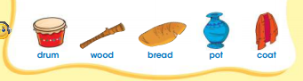

1. Ex.3 p.99. Listen and read

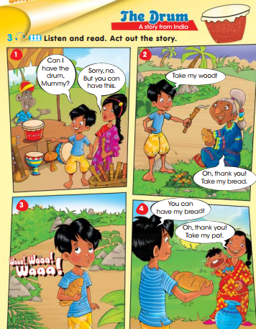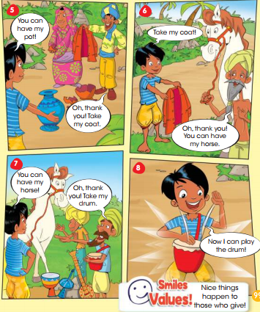

1. End.Home task .Learn by heart new words.



1. Reflection. I liked the lesson … why?

I don`t like the lesson…. Why?

National-ұлттық

Great-ұлы

Place-жер

Park-сая бақ

The twentieth of April.

Monday.

Our World time for CLIL.

Near-жақын

Beautiful-әдемі

Especially-арнайы

Hot-air balloon-әуе шары