Distance Learning at School

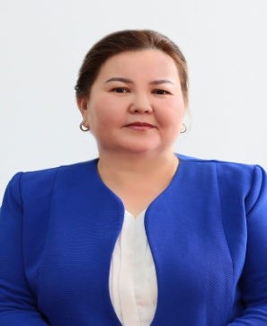

In connection with the spread of coronavirus in the country,

a state of emergency was declared, and students began to study online and remotely in the fourth semester. The question now is whether we can afford online or distance learning. If we move to this practice in peacetime, for a long time it will be said that there is an unresolved problem, and it will be postponed. This is due to the fact that many rural areas do not have access to the Internet, some schools are not fully computerized, etc. And we must choose this path right now.

In a short time, a working group was formed and specialists developed a model of the education system in a new format. “The experience of neighboring countries and international experience was studied, which introduced temporary measures to organize the educational process during the epidemic. Teachers are preparing to teach children in a new way. More than 2000 television lessons have been developed for students.

During temporary distance learning, students were provided with the necessary equipment.

We are well aware that distance learning can be a problem. If several students study in the same family, it may be inconvenient to use one computer and one smartphone or the necessary equipment may not be available at all. Some do not even have an internet connection.

The President instructed to take all necessary measures to organize distance learning.

This issue was under special control, and together with the administration, the issue of providing school computers for students and teachers for temporary use and even, if necessary, the acquisition of additional equipment (laptops or computers) for schools and their temporary use was considered. Classes are held five days a week for 30 minutes for each subject. Representatives of the Ministry teach all the country's children the best teachers of Nazarbayev Intellectual Schools, national, international and private schools.

In addition, classes on the TV channel continue on several educational resources (Bilimland, Daryn online) in accordance with the plan approved by the ministry.

In addition, the teacher and student are meeting online on the platforms Kundelik.kz, ZOOM, Google classroom, sabak.kz and practice their knowledge. Of course, standing in front of a student and teaching at a distance are two different worlds.A person has emotions.There is a way. How can we use this to teach online? There are students who understand by looking at the eyebrows of a teacher.There are many teachers who teach well through various teaching methods. In fact, some children are reluctant to accept the lesson if it is not explained in detail. Children have different levels of perception. In fact, some children are reluctant to accept the lesson if it is not explained in detail. Children have different levels of perception. However, in such a difficult time, the child should not be left without education, he should learn. The child should not be relaxed.

   In general, this is a reasonable decision.In any case, the country's students have been studying under the new system since April 6. Naturally, there is still much criticism in this regard. The ministry does not hide that there are a number of shortcomings. Due to the emergency, we moved without any preparation.The main thing is that the students do not quit studying.

In the meantime, we hope that the coronavirus epidemic will go away and we will return to normal life.