Theme of the lesson: School Days |  |  | School: №5 Akmol secondary school
Date |  |  | Teacher name: Shoshanova T.Y.
CLASS: 2 |  |  | Number present: |  |  | absent:
Learning objectives(s) that this lesson is contributing to |  | 2.L3recognise with support common names and names of places and the spoken form of a limited range of everyday and classroom words  2.L2recognise with support a limited range of basic common personal questions spoken slowly and distinctly
Lessonobjectives |  | Learners will be able to:
- recognise and write school things
- recogniseandname nouns
- listen and describe school things
Successcriteria |  | Learners have met this learning objective 2.L.3, if they can indicate 5-7 words correctly
Previous learning |  | Around school
Plan
Plannedtimings | Planned activities (replace the notes below with your planned activities) |  |  |  |  |  |  | Resources
Beginning | ORGANIZATIONAL MOMENT  Teacher : hello boys and girls!How are you?  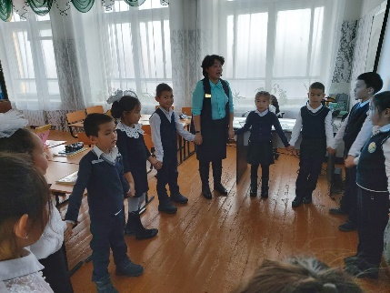  Children: hello teacher!T: Let’s remember our poem. Make the circle.  Hello! [Wave your right hand.]  Hello! [Wave your left hand.]  Hello, how are you?  I'm good! [One thumb up!]  I'm great! [Two thumbs up!]  I'm wonderful! [Jump in the air!]  And start our lesson! Divide the group. Give sun and moon in the circle.  REVISION apple tree [12apples] Now I want to know how you remember the words [ the words write in Kazakh you must English]  {Family, schoolbag, sharpener, rule, rubber, teacher, grandma, grandfather, 13, 5, 20 , 70}  Leaners sit down. Look at the blackboard. What is this? This is apple tree. You must take 1 apple and do what is written there Come here please read in Kazakh say in English If you said correctly I give marks  Marks:  green apple( no mistakes)  yellow apple (some mistakes)  3-red apple( more mistakes) |  |  |  |  |  |  | Apple tree
Middle | Ex 12. Leaners say the names school things. Count the schoolthings .and make a phrase use the words long, short, small, tree. If you said correctly I give marks  Discriptors: a leaner  . Leaners say the names  Grammatical rules зат есімнің көпше түрі  - оne book two books  - one pen three pens  - one bag five bags  Eckeрту: mouse- mice  teeth-tooth  man-men  child- children  Marks:  5- green apple  4-yellow apple  3-red apple  Ex 13. Look again read and circle. Work in the group .then read right variant.  - There are two big schoolbag.  - There are two blue rules  - There are three yellow rules.  - There are three small sharpeners  - There is one big book.  Craftwork. Закладка жасау |  |  |  |  |  |  | Apple tree  Book,
Additionalinformation
Differentiation – how do you plan to give more support? How do you plan to challenge the more able learners? |  |  |  |  | Assessment – how are you planning to check learners’ learning? |  | Health and safety check  ICT links
- More support will be given to weaker learners by giving them a modified worksheets in some tasks with greater support |  |  |  |  | - Throughformativeassessment  - Through observation of the stage of practice |  | - Healthpromotingtechniques  - Breaks and physical activities used.  - Points from Safety rules used at this lesson.  - Usevideo 10 minutes
Reflection  Were the lesson objectives/learning objectives realistic?  What did the learners learn today?  What was the learning atmosphere like?  Did my planned differentiation work well?  Did I stick to timings? What changes did I make from my plan and why? |  |  |  | Use the space below to reflect on your lesson. Answer the most relevant questions from the box on the left about your lesson.
Summary evaluation
What two things went really well (consider both teaching and learning)?
What two things would have improved the lesson (consider both teaching and learning)?
What have I learned from this lesson about the class or individuals that will inform my next lesson?

Целиноград ауданы № 5 Ақмол орта мектебі Шошанова Тлеулес Еспайевна ағылшын пән мұғалімі

