Short term plan

Term 1  Unit 2 Living things |  | School: №31
Date: 07.03.2019 |  | Teacher’s name: Bekbauova Zhanat Abduzhanatkyzy
Grade: 5 |  | Number present: | Number absent:
Theme of the lesson: |  | Plants
Learning objectives(s) that this lesson is contributing to | 5C4 Evaluate and respond constructively to feedback from others.  5L3 Understand an increasing range of unsupported basic questions on general and curricular topics.  5S7 Use appropriate subject- specific vocabulary and syntax to talk about a limited range of general topics.  5W2 Write with support a sequence of short sentences in a paragraph on a limited range of familiar general topics.
Lesson objectives | All learners will be able to:  - Identify basic questions asked and apply the topical vocabulary to talk about types of plants making short paragraphs with lots of support.  Most learners will be able to:  - Identify basic questions asked and apply the topical vocabulary to talk about types of plants making short paragraphs with some support.  Some learners will be able to:  - Identify basic questions asked and apply the topical vocabulary to talk about types of plants making short paragraphs with lots of support without support.
Assessment criteria | Give constructive feedback to each other.  Identify an increasing range of unsupported basic questions on general and curricular topics.  Apply appropriate subject- specific vocabulary and syntax to talk about a limited range of general topics.  Make up with support a sequence of short sentences in a paragraph on a limited range of familiar general topics.
Value links | The patriotic act 'Mangilik Yel' 5th value: Universal labor society
Cross curricular links | Biology
Previous learning | -
Use of ICT | Smart board for showing a presentation, playing the video files.
Plan
Planned timings | Planned activities |  |  |  | Resources
3 min  5 min  5 min  6 min  5 min  7 min  5 min | Organization moment. Teacher grades with a students  -Good afternoon children!  -Good afternoon, good afternoon, good afternoon to you, Good afternoon, good afternoon we glad to see you  Together, together, together every day, Together, together we work and play  T: How are you learners?  S: We are fine, and you?  T: I am good thank you!  T: Who is absent today?  S: All are present  T: What date is it today?  S: Today is 7th of March  T: What day of the week today?  S:Today is Thursday  Eliciting:  Conscripts and volunteers! (Whole class activity)  The teacher asks the following questions by involving active and passive students.  T: Excellent! So, children, let’s answer my questions.  1) Do you like flowers?  P: Yes, I do.  T: 2) Do you plant trees?  P: Yes, I plant trees.  T: 3) Do you water them?  P: Yes, I water them.  T: What is your favorite flower?  P1: My favorite flower is rose.  P2: My favorite flower is poppy.  T: Very good! And now, look at the white board.  How do you think students what we are going to talk about today?  -About plants  Differentiation by support: the teacher shows pictures prompts to help less able learners.  Formative assessment: The teacher assess students in oral form « excellent, very good, fine, good job »  Dividing into groups:  The teacher divides students into two groups. By giving them each one leaflets  1st group will be «Terrestrial plants»  2nd group will be «Aquatic plants»  Watching video (whole class activity)  Pre-teaching the topical vocabulary:  Terrestrial plants- This is the types of plants which grows on land  Aquatic plants- This the types of plants which grows on water  Various parts - different parts  Transfer of the water- movement of water  Seeds- What gives the birth to other plants?  Root- The part of a plant that grows under the ground?  Stem- What helps the plant to stand upright?  Differentiation by content –Teacher shows pictures of vocabulary.  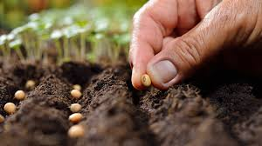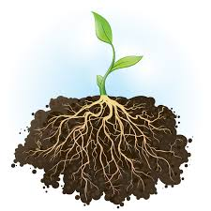  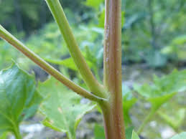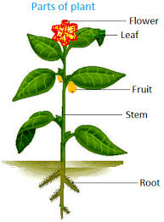  Formative asesssment The teacher assess students in oral form  (good,excellent,fine,brilliant,super)  Discover the plants! (Whole class activity)  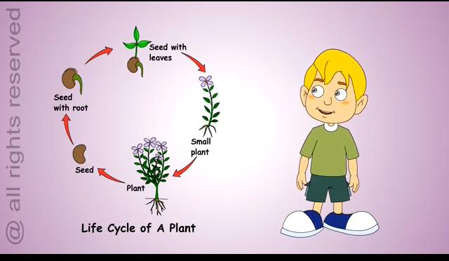  Differentiation :Teacher shows picture from white board and asks questions to explain the task  Concept checking questions  1.How do we call the process by which plants begin growing?-(Germination)  2.From what lifecycles of plants start with? –(Seed)  3.How is the plant held in the soil?-(Seed with root)  4. What may remain in the ground when the seed germinates?-(Seed with leaves)  Formative assessment: The teacher assess students with thumbs  (Excellent,good,not bad.)  Differentiation by content! (Group work)  Group A  Matching: Task for the 1st group  1 Aquatic types of plant a food  2 Terrestrial types of plant b root  3 To grow plants need c flowers  4 They give us fresh air d fishweed  5It sometimes turn into fruit seeds e grass  6 What absorbs the water f plants  Group B  Complete the sentences Task for the 2nd group. Put the words in the box to the right place  Germination terrestral plants photosynthesis fruit seeds leaves  1.__________give us flowers, fruits and vegetables.  2. We know two types of plants,they are __________and aquatic.  3. Plants has __________ which makes food for the plant flowers.  4. Flowers sometimes turn into __________.  5.__________ is the process by which plants begin growing.  6.__________ is the process by which plants make their food.  Differentiation by content: The teacher prepares two tasks to two different groups first group will match, the second group will complete the sentences.  Formative assessment: The leaders of groups assess another group with using traffic light   Interview your partner! (Pair work) Learners ask and answers the questions  Ask and answer the questions about plants:  - What plants do you know?  -Do you like plants and trees?  -Do you plant flowers trees?  -Do you have any plants at room?  Descriptor :  A learner  -asks a questions;  -answers the questions; |  |  |  | White board  Video  https://www.youtube.com/watch?v=uzIDuKVUlYk  Flash cards  https://www.google.ru/imgres?imgurl=https%3A%2F%2Fcff2.earth.com%2Fuploads%2F2017%2F09%2F18170455%2FPlant-roots-go-to-extreme-lengths-to-find-water.jpg&imgrefurl=https%3A%2F%2Fwww.earth.com%2Fnews%2Fplant-roots-find-water%2F&docid=xeE1Y6vnsmToAM&tbnid=SfCeP-lh3zzgkM%3A&vet=10ahUKEwixx5CF5OfgAhVwqIsKHcV6DeMQMwg9KAAwAA..i&w=800&h=800&hl=ru-KZ&authuser=0&bih=608&biw=1366&q=root%20of%20plant&ved=0ahUKEwixx5CF5OfgAhVwqIsKHcV6DeMQMwg9KAAwAA&iact=mrc&uact=8  https://www.google.ru/imgres?imgurl=https%3A%2F%2Fwww.motherjones.com%2Fwp-content%2Fuploads%2F2017%2F08%2F082117seeds.jpg%3Fw%3D990&imgrefurl=https%3A%2F%2Fwww.motherjones.com%2Ffood%2F2017%2F08%2F29-states-just-banned-laws-about-seeds%2F&docid=4vjWQb8bJymtiM&tbnid=nqHeUmXQNxMTMM%3A&vet=10ahUKEwjrgfy95OfgAhUopIsKHfDxCKEQMwhKKA0wDQ..i&w=989&h=556&hl=ru-KZ&authuser=0&bih=608&biw=1366&q=seeds&ved=0ahUKEwjrgfy95OfgAhUopIsKHfDxCKEQMwhKKA0wDQ&iact=mrc&uact=8  https://www.google.ru/imgres?imgurl=https%3A%2F%2Fwww.ediblewildfood.com%2Fimages%2Fstrawberry-blite-pictures%2Fstrawberry-blite-stem.jpg&imgrefurl=https%3A%2F%2Fwww.ediblewildfood.com%2Fstrawberry-blite.aspx&docid=kqJNy_rei4mvPM&tbnid=quRalqL5X70MNM%3A&vet=10ahUKEwjEnbPy4-fgAhWL6KYKHa2QAz0QMwhEKAswCw..i&w=380&h=285&hl=ru-KZ&authuser=0&bih=608&biw=1366&q=stem%20of%20plant&ved=0ahUKEwjEnbPy4-fgAhWL6KYKHa2QAz0QMwhEKAswCw&iact=mrc&uact=8  https://www.google.ru/imgres?imgurl=https%3A%2F%2Fwww.first-learn.com%2Fimages%2Fparts-of-plant.png&imgrefurl=https%3A%2F%2Fwww.first-learn.com%2Fhow-plants-grow.html&docid=dyMldKSVuOtPKM&tbnid=6PHpKE7h8KC-mM%3A&vet=10ahUKEwieydG-5efgAhXNzaYKHWmJDewQMwhBKAQwBA..i&w=291&h=395&hl=ru-KZ&authuser=0&bih=608&biw=1366&q=various%20parts%20of%20plants&ved=0ahUKEwieydG-5efgAhXNzaYKHWmJDewQMwhBKAQwBA&iact=mrc&uact=8  https://www.google.ru/url?sa=i&source=imgres&cd=&cad=rja&uact=8&ved=2ahUKEwiy_pW15ufgAhXFwcQBHa0rB_cQjRx6BAgBEAU&url=https%3A%2F%2Fwww.plymouth.k12.in.us%2Fformative%2Fsignals&psig=AOvVaw3jJna-o0TK9153Q9q6C3t5&ust=1551765307246846  https://www.google.ru/imgres?imgurl=https%3A%2F%2Fi.pinimg.com%2Foriginals%2Fbb%2F75%2F04%2Fbb75044ef5040b53111d4703047f1f38.jpg&imgrefurl=https%3A%2F%2Fwww.pinterest.com%2Fpin%2F187110559492285015%2F&docid=h9GFu-2T_bMTSM&tbnid=F3Ryg0qGJVQLJM%3A&vet=10ahUKEwiTkNPi5ufgAhXt_CoKHUfUC9cQMwh2KCwwLA..i&w=450&h=636&hl=ru-KZ&authuser=0&bih=608&biw=1366&q=traffic%20light%20formative%20assessment&ved=0ahUKEwiTkNPi5ufgAhXt_CoKHUfUC9cQMwh2KCwwLA&iact=mrc&uact=8
4 min | Feedback: Tree  At the end of the lesson students reflect on their learning:  Learners have to write their answers on the stickers and stick it on a tree:  - What have we learnt from these lesson?  - What would you like to work on?  - What would you like to learn?   |  |  |  | https://www.google.ru/url?sa=i&source=images&cd=&cad=rja&uact=8&ved=2ahUKEwjrsbCeqODgAhUQT98KHZMPCQAQjRx6BAgBEAU&url=%2Furl%3Fsa%3Di%26source%3Dimages%26cd%3D%26ved%3D%26url%3Dhttps%253A%252F%252Fwww.business2community.com%252Fcustomer-experience%252Fcustomer-feedback-is-the-oxygen-of-social-enterprise-0559540%26psig%3DAOvVaw0gezeOgqUWw4PzVa-uLoFu%26ust%3D1551508091450835&psig=AOvVaw0gezeOgqUWw4PzVa-uLoFu&ust=1551508091450835
End  1min | Feedback: Teacher asks students what task was difficult to them and which pair worked well.
Additional information
Differentiation –  how do you plan to give more support? How do you plan to challenge the more able learners? |  | Assessment –  how are you planning to check learners’ learning? |  | Health and safety check
Eliciting:  Conscripts and volunteers!  Differentiation by support: the teacher shows pictures prompts to help less able learners.  Concept checking questions  Differentiation by content –Teacher shows pictures of vocabulary  Discover the plants!  Differentiation :Teacher shows picture from white board and asks questions to explain the task  Matching:  Differentiation by content: The teacher prepares two tasks to two different groups first group will match, the second group will complete the sentences. |  | Eliciting:  Conscripts and volunteers!  Formative assessment: The teacher assess students in oral form « excellent, very good, fine, good job »  Concept checking questions  Formative asesssment The teacher assess students in oral form (good,excellent,fine,brilliant,super)  Discover the plants  Formative assessment: The teacher assess students with thumbs  (Excellent,good,not bad.)  Matching:  Formative assessment: The leaders of groups assess another group with using  traffic light  Interview your partner! (Pair work)  Descriptor :  A learner  -asks a questions;  -answers the questions; |  | The teacher will say that some plants are poisonous and they should not touch them.
Reflection
- Were the lesson objectives/learning objectives realistic?
- Did all learners achieve the lesson objectives/learning objectives? If not, why?
- Did my planned differentiation work well?
- Did I stick to timings?
- What changes did I make from my plan and why?
Summary evaluation
What two things went really well (consider both teaching and learning)?
1:
2:
What two things would have improved the lesson (consider both teaching and learning)?
1:
2:
What have I learned from the lesson about this class or individuals that will inform my next lesson?

