School № 10, Kostanay |  | Long-term plan unit: 7 The natural environment
Date: |  | Teacher name: Imasheva G.K.
Grade: 2 |  | Number present: | Absent:
Theme of the lesson: Sea adventures

Learning objectives that this lesson is contributing to |  | 2.S3 pronounce familiar words and expressions intelligibly  2.L3 recognize with support common names and names of the topic recognize the spoken form of a limited range of everyday and classroom words  2.UE10 use common present continuous form to talk about what is happening now
Lesson objectives |  | All learners will be able to:  - understand and follow instructions (65-70%)  - make simple sentences to describe actions in Present Continuous in their speech with support  Most learners will be able to:  - pronounce words and expressions intelligibly (70-75%)  - construct more creative sentence in Present Continuous in their speech with little support  Some learners will be able to:  - complete all tasks quicker and correctly (80% and above)  - use Present Continuous in their speech without any support
Success criteria |  | Student achieved the LO (S3), (UE10) if he can:  pronounce more than 7 words intelligibly,  use Present Continuous Tense in 1-2 sentences
Value links |  | Education throughout life
Cross curricular links |  | The world around us
ICT skills |  | Using SMART board, pictures and videos, working with URLs
Previous learning |  | Learners need to be familiar simple present and present continuous forms, and basic vocabulary for talking about the weather and seasons
Plan
Planned timings | Planned activities |  |  | Resources
Beginning  3 min | ORGANIZATIONAL MOMENT  Activity 1 Creation of positive atmosphere. (Morning circle)  Teacher greets students; students respond to greeting and asks a couple of familiar questions to make sts think in English:  - How are you?  - What day is it today?  - What is the weather like today? |  |  | PPT
Middle  35 min | Activity 1 Speaking  Task 1 (Guessing method)  -Teacher demonstrates sts a picture which illustrates a sea scene as well as kids doing different things and asks sts to try to guess about the topic of the lesson  - sts share their ideas, which teacher puts on the board  - at the end teacher introduces the topic (Sea adventures) and finds out who was the closest to the correct answer and gives that student a praising sticker  Task 2. Learning and lesson objectives are introduced.  Task 3.(Presentation)  - using PPP, teacher introduces vocabulary on the topic; teacher reads words and sts repeat.  - when all words are introduced, teacher nominates a couple of students to read the whole list of words for the class.  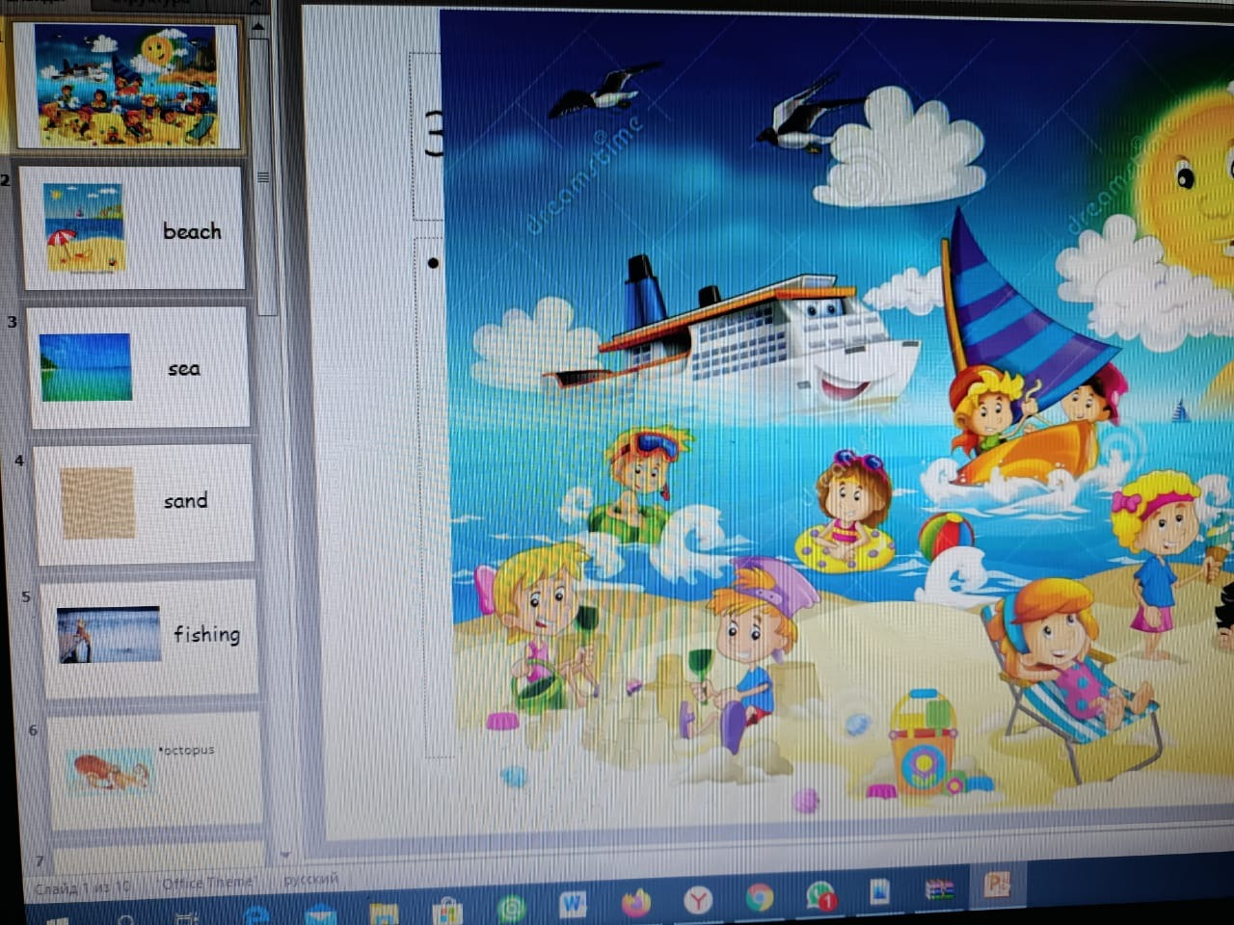  Task 4.(Scrambled words)  - once all words have been read and drilled, teacher puts up jumbled words for learners to un-jumble and sound  What sea animal is it?  Task 5. Fill in the missing letters in the names of underwater animals. Read them.  Example: The shell is on the beach.  1. The o _ _ _ _ _ _ is very clever.  2. The s _ _ _ _ is very angry.  3. The w _ _ _ _ is very kind.  4. There are many s _ _ _ _ _ on the beach.  5. The water in the sea is b _ _ _ .  .  Task 6. (Multimedia ICT technology)  - Fix the pronunciation of words by following the link and watching the video  Activity 2 Writing  Task 1. Read. Using the pictures put the cards in order  1. Hello, my name is Leo. I am a fish. I am swimming right now in a blue ocean.  2. I am going to sleep, says Grandpa. Be a good boy, do not go far away.  3. Hello, says green Timmels, the turtle. Let’s go.  4. Oh, no! It’s a Black shark! It is going to eat us!  5. Dori, a big fish is coming to help her friends. Thank you, Beautiful Dori!  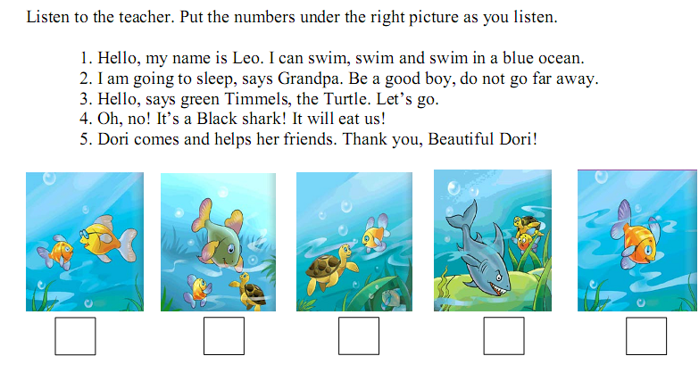  Task 2. (Picture method)  Listen to the teacher, write the names  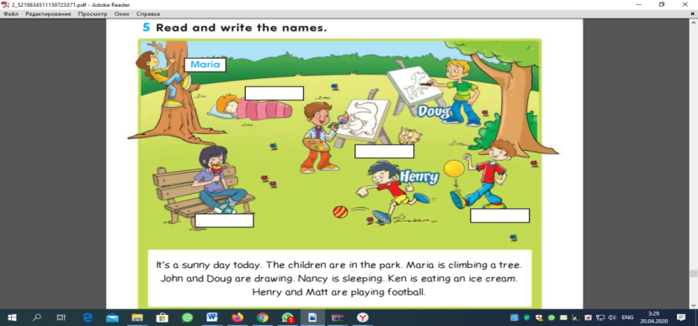  - using the same scene card teacher explains the idea of using present continuous forms in speech in order to describe what is happening now and models a couple of examples on the board.  Dynamic pause (Multimedia)  Task 2 Grammar. Forming.  Present Continuous Tense  To be + V ing  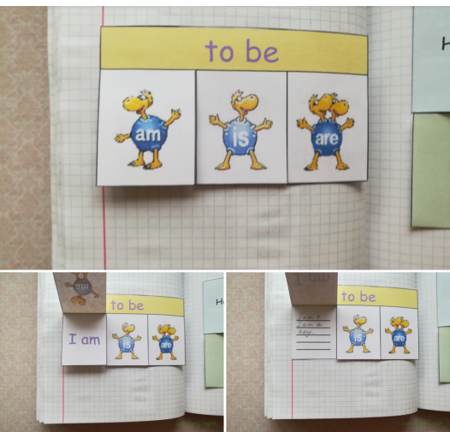  Task 3 Write Verbs.  V+ing  1 wear – wearing  2 eat – _____________________________  3 play – ____________________________  4 listen – ____________________________  5 read – ____________________________  6 climb – ___________________________  7 jump – ___________________________  8 fly – ______________________________  9 sing – _____________________________  10 sleep – ___________________________  Peer-assessment. Learners give their feedbacks by drawing smiles.  Activity 3 Practice  Task 1 Read and translate.  - She is reading right now  - He is sleeping now.  - They are playing at the moment.  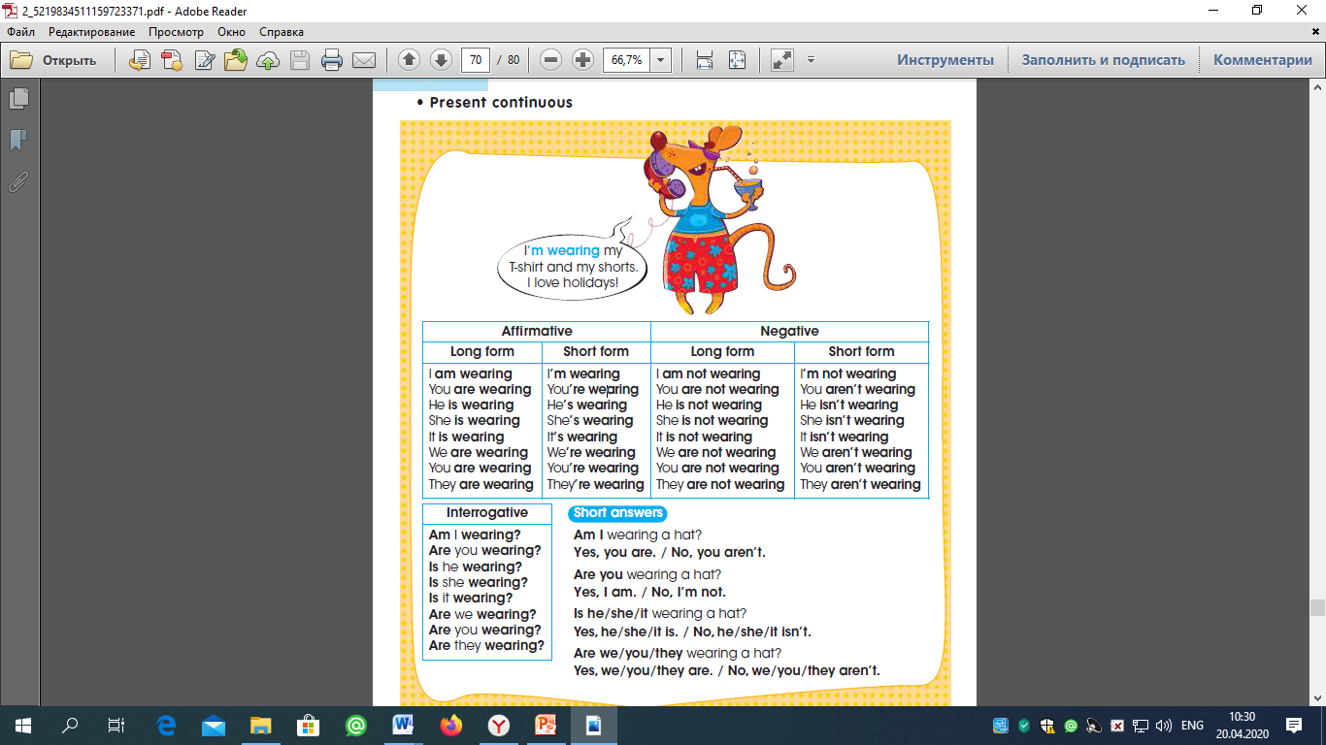  Task 2 Fix the grammar by following the link  Self-assessment. Learners check themselves by given keys.  Activity 4.  Home work: New words learn by heart.  Complete the sentences  1 Complete the sentences. Use am, is or are.  1 I am singing.  2 She ________ playing in the garden.  3 They ________________ drinking milk.  4 Dad ___________________ sleeping.  5 I __________________ eating a pear.  6 It __________________________ flying.  2 Make sentences.  1 wearing/yellow/I’m/dress./a  I’m wearing a yellow dress.  2 wearing/skirt./an/She’s/orange  __________________________________  3 They’re/hats./blue/wearing  __________________________________  4 T-shirt./green/wearing/I’m/a  __________________________________  5 wearing/red/We’re/shorts. |  |  | A picture of a sea scene  PPP  A picture of a sea scene  https://www.youtube.com/watch?v=Oxw6FoUNeT4  https://yandex.kz/video/preview/?filmId=3808140852530335770&reqid=1587359381243201-692075759429410832100110-man2-6233-V&suggest_reqid=917715581157000482893881626745084&text=maple+leaf+learning+sea+animals  https://yandex.kz/video/search?text=maple%20leaf%20learning%20present%20continuous%20  https://www.liveworksheets.com/worksheets/en/English_as_a_Second_Language_(ESL)/Present_continuous/Present_continuous_zn38395eq  Cards
End  2 min | Reflection (Islands method)  Learners give their feedback and put the stickers into definite island.  understand  difficult  Boring

