Short term plan

Lesson plan
Unit of a long term plan |  |  |  | School: 11
Date: |  |  |  | Teacher name: Aigerim Zhumasheva
CLASS: 2 |  |  |  | Number present: | absent:
Lesson title |  | Our body
Learning objectives(s) that this lesson is contributing to (link to the Subject programme) |  | 2.R1 read and spell out words for others  2.S3 use a limited range of basic words, phrases and short sentences to describe objects, activities and classroom routines  2.UE6 use demonstrative pronouns this, these, that, those to make and respond to requests for information
Lesson objectives |  | All learners will be able to:  Spell out words  Describe words, phrases connected with objects, activities and classroom routines using main vocabulary  Identify demonstrative pronouns  Most learners will be able to:  Read the words with accuracy  Name the body parts using demonstrative pronouns  Some learners will be able to:  Complete the words with correct letter  Make short sentences to describe objects, activities and classroom routines
Assessment criteria |  | Use demonstrative pronouns in their answers  Apply vocabulary words in their speech  Read and spell out words correctly
Values links |  | Common history, culture and language
Cross-curricular  links |  | Biology
Previous learning |  | They know the words nose,head,hand ( grade1)
Plan
Planned timings | Planned activities (replace the notes below with your planned activities) |  |  |  |  |  | Resources
Start  4-7 min | (W) Learners watch the video and sing a song ''Hello''.  (W) .Warm up.  Picture cover up.Strategy « Pictionary».  Learner should choose one picture, cover it up to whole class and show one of the part to let them guess the covered part.  Group division  Learners should find the piece of the paper under the desk. Then they make up the piece of picture and find your teams .  1 group- Ears  2 group- Face  3 group – Hand |  |  |  |  |  | https://youtu.be/tVlcKp3bWH8  card  .Iris.press
Middle  4 min  9 min  Descriptor  6 min  8 min | (W) New vocabulary. Strategy “Drilling”  Learners should listen the new words and repeat after the teacher. After teacher present with actions and learners show  Eyes  Ears  Shoulders  Knees  Hands  Legs  Mouth  Hair  FA “Smiles stikers”  (W).Task 1.Strategy “Choral”.  Learners read the poem about all of me and repeat.  All of me  By Jessica McDonald  My hands are for clapping  My arms can hug tight  My fingers can snap  Or can turn out the light  My legs are for jumping  My eyes help me see  This is my body  And I love all of me.  FA by thumbs  (W).Demonstrative pronouns this ,that, these, those .Explain with examples.  This –Singular, near. This is apple  That-singular ,far. That book  These-plural, near .These books  Those- plural, far. Those chairs.  (P) Task 2.Strategy “Gap filling”.  Complete the sentences with this,that,these,those  1. ……….. is computer.  2.………….. are books.  3…………… are chairs.  4.……………..is pencil.  A learner  -Fills the gap  -writes appropriate words  FA. Peer assess each other with “Pluses and minuses”.  Differentiations by time allowed  (I).Task 3. Strategy “Unscrambling and Matching”.  The letters unscrambled. You should put letters in the correct order and match with picture.  UHTOM  YSEE   SLUDROSEH  OESN 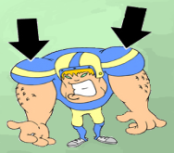   GSEL  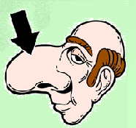  FA with medals.  Differentiations by scaffolding.  (W) Task 3.Wake up activity. Strategy TPR  Learners stand up and watch the video , do exercises with teacher  FA by clapping hands.  (G) Task 4.Strategy “Protecting poster”  Teacher distribute puzzles of picture in the envelope and learners should stick the puzzles to the poster and make up .After that learners write the parts of the body correctly. Then they present to whole class using the demonstrative pronouns.  FA with teacher motivation words. |  |  |  |  |  | PPT  PPT  mycutegraphics.com  poem by Jessica McDonald  board,chalk  Handout 1  Handout 2  https://youtu.be/h4eueDYPTlg  poster,glue,marker
End  5 min | Plenary task. Strategy by «Drawing your brain».  Learners take one sheet of paper and pencils.Listen to me ,close your eyes. Draw a head, draw eyes, nose,ears,hair,shoulders and legs.  Feedback. Traffic lights.  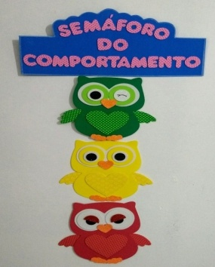  I liked….;  It was difficult for me…..  I didn`t like …… |  |  |  |  |  | Sheet of paper
Additional information
Differentiation – how do you plan to give more support? How do you plan to challenge the more able learners? |  |  | Assessment – how are you planning to check learners’ learning? |  |  | Health and safety check
Differentiation by scaffolding:  Strong learner support to if week learner didn`t know answer  Differentiation by time allowed: teacher gives extra time for learner if it is necessary for learners |  |  | Strategy “Drilling”  Formative assessment “Smiles stikers ”  Strategy “ Protecting poster “  Group assessment with teacher motivation words  “Strategy “Gap filling”.  Peer assessment with “Pluses and minuses”.  Strategy “Unscrambling”.  Self assessment with medals

