Short-term plan  Unit 6 Lesson 7:Traditions and Language |  |  |  | School: № 57
Date: 17.02.2020 |  |  |  | Teacher name: G.E. Smailova
Grade:9 С |  |  |  | Number present: |  | absent:
Theme of the lesson:Eco-festivals
Learning objectives | 9.1.8.1 - develop intercultural awareness through reading and discussion;  9.1.10.1 - use talk or writing as a means of reflecting on and exploring a range of perspectives on the world  9.4.2.1 - understand specific information and detail in texts on a range of familiar general and curricular topics, including some extended texts;  9.4.4.1 - read a range of extended fiction and non-fiction texts on familiar and unfamiliar general and curricular topics;  9.4.5.1 - deduce meaning from context in extended texts on a range of familiar general and curricular topics;  9.4.7.1 - recognize typical features at word, sentence and text level in a wide range of written genres;  9.5.2.1- write independently about factual and imaginary past events, activities and experiences on a range of familiar general and curricular topics;
Lesson objectives | All learners will be able to  identify some specific information in texts and research and write short organised text using some of their own words
Most learners will be able to
identify most specific information in texts and research and write short organised text using a range of their own words
Some learners will be able to
identify all specific information in texts and research and write more extended organised text using a range of their own words
Assessment criteria | Ss can present the activities for the Brighter Together Festival
Previous learning | buying a gift
Plan
Planned timings |  | Planned activities (replace the notes below with your planned activities) |  |  |  |  | Excel  Resources
Home task  Beginning the Lesson |  | Check the new words Play the game “ Bang- bang”  To show for students presentation about Eco - Festival  To introduce the topic and predict the content of the text  - Direct Ss’ attention to the pictures and the headings  - Elicit what Ss think people can do at eco-festivals  - Play the recording  - Ss listen and follow the texts in their books and find out |  |  |  |  | PPT  P 71ex1
Main Activities |  | To read for specific information ( comprehension questions)  - Give Ss some time to read the text again and answer the questions  - Check Ss’ answers  - Refer Ss to Word List to look up the words in the Check these words box  - Play the video for Ss and elicit their comments  To summarise the main idea of the text  - Read out two sentences  - Elicit which one best summaries the main idea of the eco-festivals  - Venn diagram  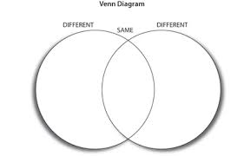  To learn and practise prepositional phrases  - Explain the task  - Give Ss time to complete it  - Check Ss’ answers around the class |  |  |  |  | P 71 ex2  P 71 ex3  P71ex 4
Ending the lesson |  | To play the “Domino” game  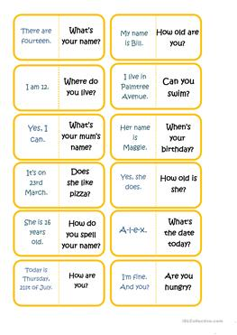
Home task |  | - Decide on activities for the Brighter Together Festival when it visits your town/ city. Write down your ideas. Then Present them to the class |  |  |  |  | P71 ex 5
Additional information
Differentiation |  |  | Assessment |  | Cross-curricular links  ICT links
- prompt less able learners to engage in whole class checking and group activity with supportive questioning  - challenge more able learners to come up with a strategy for effectively recording different types of vocabulary presented in this lesson |  |  | Through questioning, observation and praising words  -check pronunciation of new words and reinforce with drilling where necessary  assessment criteria:  -Ss can present the activities for the Brighter Together Festival |  | cross curricular links: world festivals

