LESSON 6: Unit 3 Days of the week  2A. Classroom objects |  |  | School:
Date:14.09.2020 |  |  | Teacher`s name: Abilmazhinova A.B AAAAKiLAbduA.Zh.https://www.youtube.com/watch?v=hq3yfQnllfQ
Grade: 3 |  |  | Number present: |  |  | absent:
Learning objectives(s) that this lesson is contributing to |  |  |  | 1.L3 recognise with support common names and names of places; recognise the spoken form of a limited range of everyday and classroom words  1.R1 recognise sound and name the letters of the alphabet  1.S1 make basic personal statements about people, objects and classroom routines
Lesson objectives |  |  |  | All learners will be able to:
 |  |  |  | - Name 7 days of the week with support
 |  |  |  | Most learners will be able to:
 |  |  |  | - Name 7 days of the week with some support
 |  |  |  | Some learners will be able to:
 |  |  |  | - Name 7days of the week
Success criteria |  |  |  | Learners have met the learning objective (R1) if they can:  Recognize letters in names of the days  Spell the words correctly
Value links |  |  |  | Respect/cooperation
Cross-curricular links |  |  |  | Science
ICT skills |  |  |  | Using videos& pictures, working with URLs
Previous learning |  |  |  | Vocabulary from previous two units
Plan
Planned timings |  | Planned activities (replace the notes below with your planned activities) |  |  |  |  |  | Resources
Beginning  10 min  (W) |  | Greeting, Warm up:  Greet the students. "Hello!"/"Good morning!"/"Good afternoon!"“How are you?”  As a warming up, have learners remember the letters of the alphabet ABCDEFGHIJKLMNOPQ and name them. Ask learners to name any words they remember which start from these letters “ABCDEFGHIJKLMNOPQ”.  Introduce two more letters Rr;Ss;  - Learners are given overwriting worksheets to practice writing letters Rr;Ss.
Middle  15 min  (IW)  10 min  (IW) |  | - Introduce the topic of the lesson, have learners look at the board.  Demonstrate the days of the week.    - Suggest learners to listen to “Days of the week” song.  - As a whole class practice pronunciation of the words.  - Ask what day it is today.Today is Tuesday.  - Learners watch a video about 7 days of the week.  - Give learners worksheets to glue into their vocabularies.  Dynamic break:  - Learners stand up in a big circle and follow the movements.  Overwriting practice.  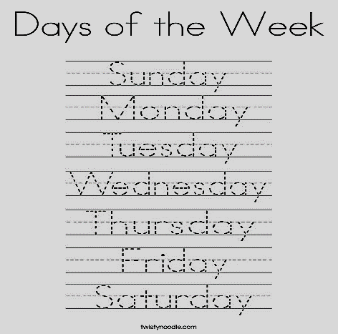  - Check learners’ writings and give them stickers.
End  5min |  | Closing/Reflexion  - Ask learners what days they remember  - Show days cards and ask what day was difficult/easy to remember.
 | Additional information
 | Differentiation – how do you plan to give more support? How do you plan to challenge the more able learners? |  |  |  | Assessment – how are you planning to check learners’ learning? |  | Cross-curricular links  Health and safety check  ICT links  Values links
 | - more support can be given during elicitation, instruction and questioning phases of the lesson by nominating learners to answer items relating to more high frequency vocabulary to build confidence through participation. |  |  |  | - through assessment task  - through observation |  | - Art  - Social studies
 | Reflection  Were the lesson objectives/learning objectives realistic?  What did the learners learn today?  What was the learning atmosphere like?  Did my planned differentiation work well?  Did I stick to timings? What changes did I make from my plan and why? |  |  | Use the space below to reflect on your lesson. Answer the most relevant questions from the box on the left about your lesson.

