Long-term plan unit:  Unit: “Healthy habits” |  |  | School:  TurarRyskylov school -lyceum
Date: |  |  | Teachername: ZhumagulovaBalzhan
Grade:7 |  |  | Numberpresent: |  | absent:
Theme of the lesson“Healthy habits living”
Learning objectives that this lesson is contributing to |  | 7.2.2.5 understand most specific information and detail of supported, extended talk on a range general and curricular topics  7.4.4.1understand the main points in texts on a limited range of unfamiliar general and curricular topics  7.3.3.7 use appropriate subject-specific vocabulary and syntax to talk about a range of general topics, and some curricular topics
Lessonobjectives
All learners will be able to:
- recognize topic related words from the video;
-read and identify the main ideas of the topic
-talk about healthy habits
Assessment criteria |  | -witch the video and answer the questions  -identify express opinion about food pyramid
Levelofthinkingskills |  | Understanding, Application
ICT |  | Projector or Smart board for presenting a PPT
Valuelinks |  | HealthyLife,Responsibility.
Cross-curricularlinks |  | Biology, PE
Previouslearning |  | Names of food and spor
Plan
Plannedtimings | Plannedactivities |  |  |  |  |  |  | Resources
Start  5min | W Greeting:  Teacher startes theme of the lesson with rebus  `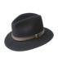” ‘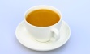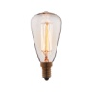”’1000””’  I.(W)Students watch the video and listen to the song. Teacher asks some questions to elicit the theme of the lesson .  What was the video about?  What familiar words have you heard in the song?  What do you think what are we going to speak about today?  Teacher gives instructions to divide into small groups:  1 group “Healthy” 2 group “Unhealthy” 3 group “Habits”
Middle  30 mins  5 min | II .(group work)Read the text and answer the questions  A Healthy lifestyle  The Thomson family has been trying to eat healthy meals for every long time , but found it difficult to keep it up. Mr. and Mrs. Thomson work a long hours at the hospital , and feel exhausted when they arrive at home. Also they have three young children who needed a lot of care. David is 8 years old, their daughter Ann is six and the baby is one . It is difficult for the family to cook healthy meals every day.Formonths ,Mrs Thomson has been ordering food during the week, which is delivered after they arrive from work.This is bad routine ,and the Thomson ‘s know this fact every well and have started to worry that their children will get so used to eating fast food; it will be difficult for them to change this habbit. For the past two weeks , they have been eating healthy homemade meals and feel very excited about it.  Basketball questions  1. Does the Thomson family eat healthy meals?  2. How many children they have?  3. Who orders food every day?  4. Are they worried about their bad eating habits?  5. Do you think they will continue to eat homemade food?Why?  Descriptor: A learner  * reads the text ;  * answer the questions  III.Speaking  1) Now, learners what can you see on the board?  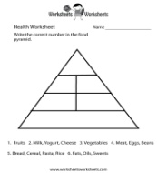  Food Pyramid is a diagram that represents a healthy diet by placing food groups in a pyramid according to the number of servings from each group to be eaten every day.  Making a poster. (G)  *Each group draws a pyramid and fill the pyramid with different foods. At the top of it, write the name of category the list of healthy products, at the bottom- of the healthiest one  * Learners from each group show their pyramids and justify their answers. Others may comment and evaluate, or contradict.  Differentiation  1)Tasks for less able learners:  Makes true and false statements:  - It is important to eat a variety of foods. (T)  - Bread contains vitamins and minerals. (T)  - All fatty foods are bad for us.(F)  Tasks for most of learners : answer to the questions:  * Which food group should you eat the most of?  * How do you think what is the most healthy food?  Tasks for some of learners :  - Creates food pyramid  - presents the poster of food pyramid  Learners are shown the original Food Pyramid to check their answers.  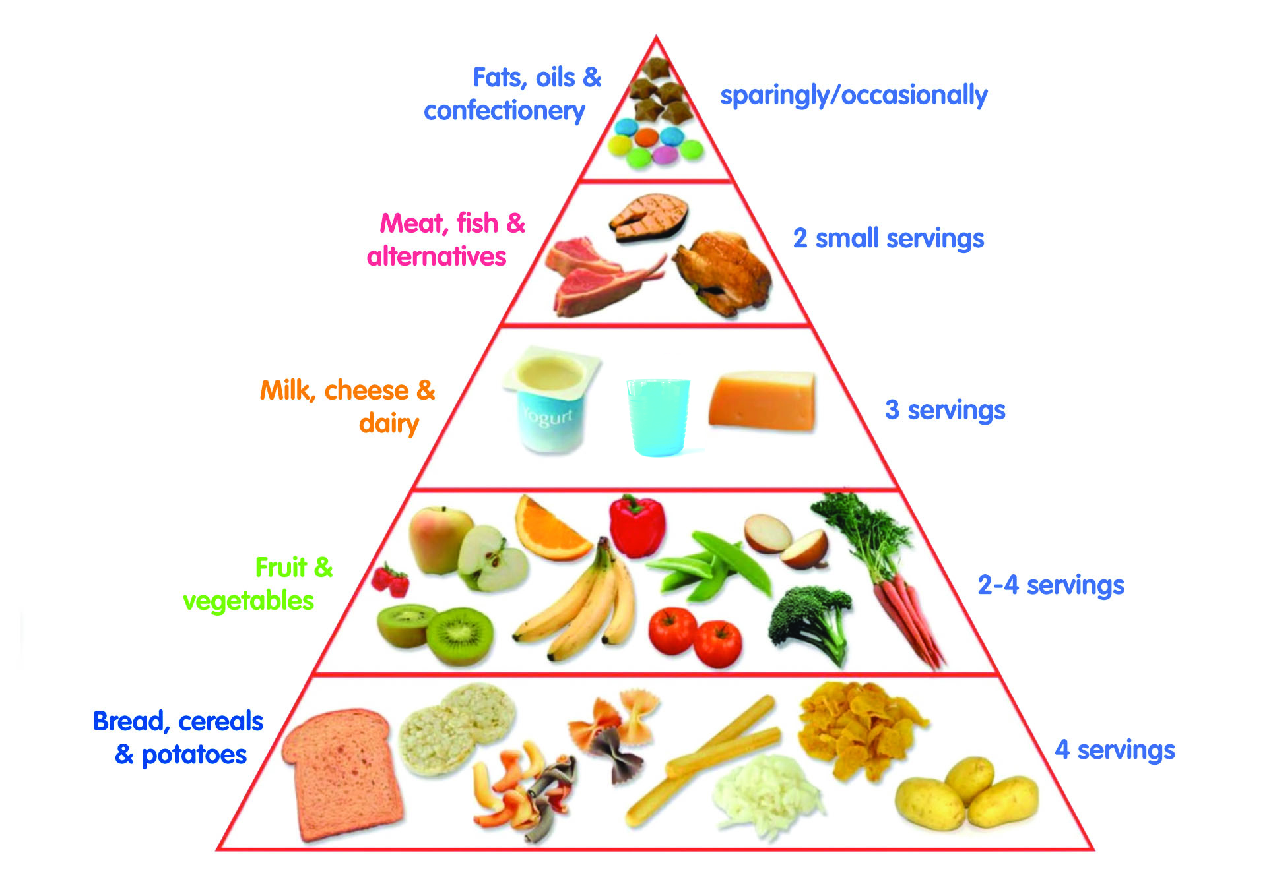  Descriptor Points  creates a poster  answers the questions  presents poster  Feedback  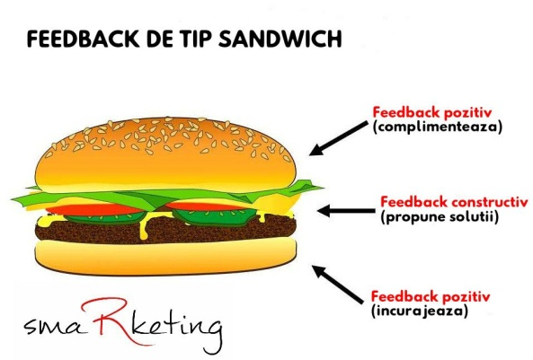  Part 1 positive view, what did I like  Part 2 constructive view, what should be improved  Part 3 recommendations for the future: I liked it, but the next time….. |  |  |  |  |  |  | PPT Healthy habits song https://www.youtube.com/watch?v=9Fr1iDqemjY  Cards  http://ck.ot7.ru/uploads/7/2/9/Piramida-pitaniya_72982.jpg  marker  poster  http://konradvest.com/wp-content/uploads/2017/09/food_pyramid-1024x718.jpg
End
5 mins
Additionalinformation
Differentiation – how do you plan to give more support? How do you plan to challenge the more able learners? |  |  |  | Assessment – how are you planning to check learners’ learning? |  |  | Health and safety check
Most support:  Make sure that they try to justify personal opinions while giving the answers.  Minimal support: Help less able learners with the marking sentences with True or False |  |  |  | Peer assessment: Descriptor. Sandwich feedback |  |  | - Work with the SMART board not more than 10 minutes  - Usewaterbasedmarkers  - Ensureproperventilation  - Checksockets’ safety  - Monitor classroom space when students start moving around during dynamic break
Reflection  Were the lesson objectives/learning  objectives realistic?Did all the learners  achieve lessonobjectives/learning  objectives?Did my planned  differentiationwork well? |  |  |  |  |  | The lesson objectives/learning objectives were realistic. Learners achieved lesson and learning objectives. All learners were involved in the learning process. Learning atmosphere was collaborative and friendly. I am sure that my planned differentiation work well. Differentiated task helped to involve all learners to the lesson.
Summary evaluation
What two things went really well (consider both teaching and learning)?
1:Filling the Food Pyramid and the poster preparing task.
What two things would have improved the lesson (consider both teaching and learning)?
1: It would have been better to use more pictures.
What have I learned from this lesson about the class or individuals that will inform my next lesson?
1: Students’ speaking skills should be improved

