*Маңғыстау облысы, Ақтау қаласы*

*Исатай Сүйеубаев атындағы №8 жалпы орта білім беретін мектебі*

*коммуналдық мемлекеттік мекемесі.*

***Intellectual game lesson***

***“Enjoy the stations”***

*Орындаған:Өмірзақова Д.Б*

*Сыныбы: 5*

**Ақтау 2018 жыл**

Good afternoon, dear teachers and pupils! Welcome to our Intellectual game “Enjoy the stations” among 5th grade.

I divided you into 3 groups. Let me introduce you groups: Clevers, Stars,

**Our game consists of 10 stations.**

***Station 1.*** *Name as many words as you can beginning with the letter “B” I’ll give you 2 minutes.* ***(1 word – 1 point)***

*S****tation 2 .*** *Match words with their transcriptions.* ***(1 word - 1 point)***

|  |  |
| --- | --- |
| Kate late fly line name Steve play read pencil kite | [kait] [ri:d] [lain] [pensl] [plei] [keit] [flai]  [sti:v] [neim] [leit] |

*S****tation 3.*** *Find antonyms to these words*



***Station 4.*** *Tongue twisters. I’ll give 2 minutes, then each groups read out tongue twisters without mistakes properly and faster.*

1. **If you, Sandy, have two candies**

**Give one candy to Andy, Sandy**

**2. A cup of coffee from a copper coffee pot**

**3. A little pot is soon hot**

**4. Bobby brings bright bells**

**5. Seven Santas sing silly songs**

***Station 5.*** *“Odd Word*” *Find one extra word in each line*

blue, black, pink, yellow, melon

speak, answer, sing, breakfast, translate

potato, tomato, carrot, pear, tree

tiger, lion, bird, elephant, rabbit

summer, winter, rain, spring, autumn

carpet, sausage, apple, juice, cheese

teacher, pupil, blackboard, manager, book

tail, cat, mouse, dog, rabbit

English, Russian, Phone, Sport, Mathematics

peach, pear, chicken, apple, banana

**Station 6.** *«Sign the items in the picture»*

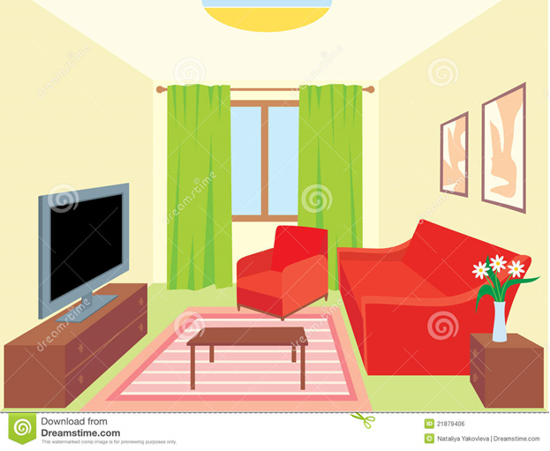

***Station 7*** *«Check the rules, plural forms»*

1) a tooth – teeth

2) a child-children

3) one fish- twenty fish

4) a city-cities

5) a fox-foxes

6) a boot- boots

7) a mouse -mice

8) a woman –women

9) a fly- flies

***Station 8.*** *“Countries” – match the country with its capital:*

Russia – Moscow, the UK – London, the USA – Washington, Germany – Berlin, Italy – Rome, Spain – Madrid, France – Paris, Brazil – Brasilia, Japan – Tokyo, Ukraine – Kiev. (2 points for each correct answer)

***Station 9****. “Mistakes” find a spelling mistake in one word of each sentence.*

I have brekfast at eight.

Her mather and father are teachers.

She is a doktor.

Five plus seven is tvelve.

My cat is fat and fanny.

The boy likes to sleep in a big ded.

His sun is good at Sport.

I like to drink koffee.

March, Aprel and May are spring months.

Nick’s eyes are broun.

***Station 10.*** *Make words from these letters.*

|  |  |  |
| --- | --- | --- |
| **№** | **words** | **animals** |
| 1 | **usemo** | mouse |
| 2 | **rietg** | tiger |
| 3 | **owc** | cow |
| 4 | **lofw** | wolf |
| 5 | **areb** | bear |
| 6 | **seogo** | goose |
| 7 | **btabri** | rabbit |
| 8 | **pehes** | sheep |