«Малонарым орта мектебі» КММ

Абай Қунанбаевтың 175-жылна арналған

аудандық семинар

Ағылшын тілі пәні ашық сабақ

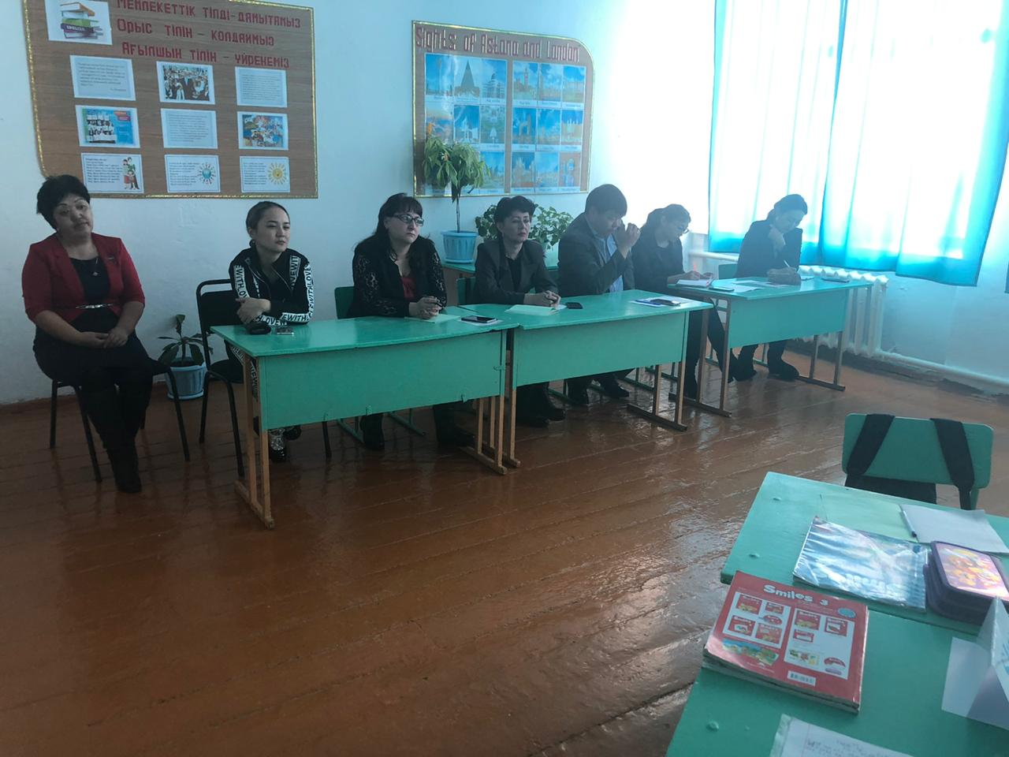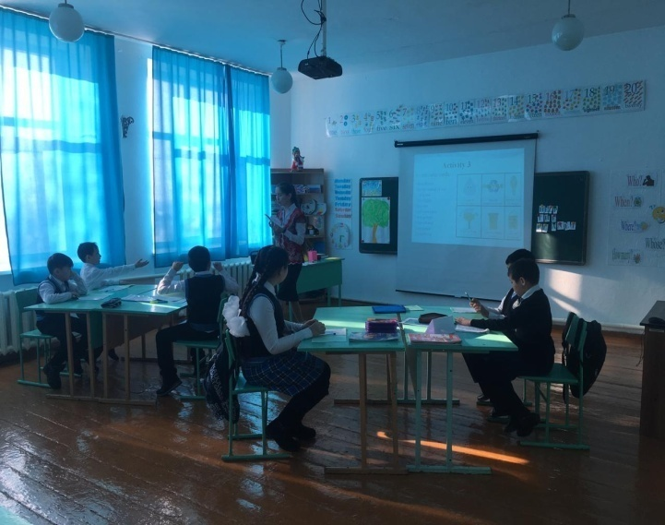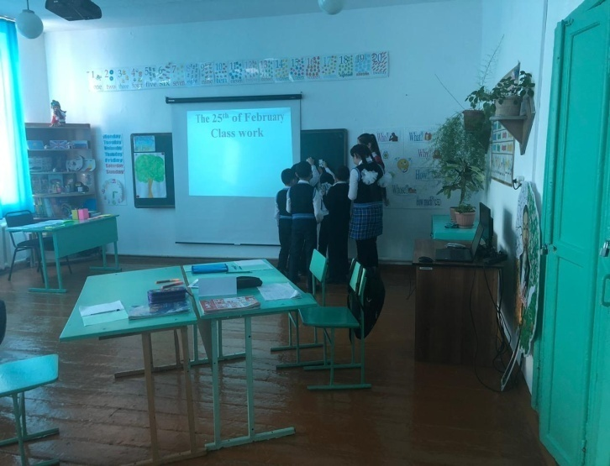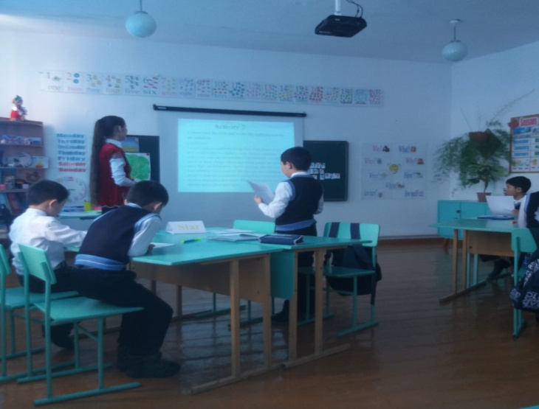

Пән мұғалімі: Қаухан Мәрия

2019-2020 оқу жылы

|  |  |  |  |  |  |
| --- | --- | --- | --- | --- | --- |
| **Short-term plan**  **Term 3 Unit5.** | | | **School:** Malonarym’s secondary school | | |
| **Date:25.02.2020** | | **Teacher’s name: Kaukhan Maria** | | | |
| **Grade:** 3a-4a | | **Number present:6** | | **Absent:6** | |
| **Theme of the Lesson:** | | Help the planet | | | |
| **Learning objective(s) that this lesson is contributing to and assessment criteria** | | 4.R1 learners will use their glossaries and try to understand the text.  4.L2 Pupils after listen 10 sentences, find these sentences saver or waster during guided reading activities. | | | |
| **Lesson objectives** | | Most learners will be able to:   * Understand 2-3 questions and reply correctly * Choose the right 7-8 words and spell them correctly | | | |
| Some learners will be able to:   * Understand most of the questions and reply correctly * Choose the right 10 words and spell them correctly | | | |
| A few learners will be able to:   * Understand all the questions and reply correctly * Choose the right 12-13 words and spell them correctly | | | |
| **Assessment criteria** | | Complete at least 80 % of task correctly | | | |
| **School’s mission, vision and Global Citizenship** | | Skills for life-long learning.  Understanding cultural diversity, being ready for intercultural communication and changes | | | |
| **Value links** | | Work in group, academic honesty, respect to each other working in groups | | | |
| **Cross curricular links** | | natural recognition | | | |
| **ICT skills** | | PPT by the teacher | | | |
| **PastoralCare** | | Treat student’s as individuals and address their learning and personal needs | | | |
| **Previous learning** | | Planet | | | |
| **Health and safety** | | Short physical exercises in between the activities | | | |
| **Plan** | | | | | |
| **Planned timings** | **Planned activities** | | | | **Resources** |
| **Beginning**  **10 min**  10 min. | **Greeting**  -Good morning, boys and girls!  -Good morning, teacher!  -How are you today?  -We are fine, thank you!  -What date is it today?  **Home task check**: what kind of animals do you know?  **Make two group: use tarsia method** | | | |  |
| **Middle**  **25 min**  2 min  5 min  10 min    3 min  5min | Teacher shows the slide 1 and presents the topic and objectives of the lesson.  **Activity 1**  **Find the theme**.   |  |  |  |  |  |  |  |  |  |  |  |  |  | | --- | --- | --- | --- | --- | --- | --- | --- | --- | --- | --- | --- | --- | | H | E | L | P | T | H | E | P | L | A | N | E | T |   C:\Users\User\Desktop\25.20.2020Семинар\photo\017495_Ampliada.jpgC:\Users\User\Desktop\20.20.2020Семинар\earth-day-activities.png  **New vocabulary:**  1.Garbage [ˈgɑːbɪʤ] - қоқыс  2.Pollution [pəˈluːʃn] – ластану  3.Energy [ˈenəʤɪ] –энергия  4.Earth [ɜːθ] – жер  5.Save [seɪv] – үнемдеу, құтқару  6.Plastic [ˈplæstɪk] – Пластикалық  7.Factory [ˈfæktərɪ] – зауыт  8.Environment [ɪnˈvaɪərənmənt] - қоршаған орта  **Activity 2**  C:\Users\User\Desktop\20.20.2020Семинар\1396393080_earth-day.pngPut learners into work and let them read the text, learners will use their glossaries and try to understand the text. After reading teacher will let them to answer the questions.  Then they join in groups and compare their answers. After that teacher shows correct answers.  **Physical moment**  **Activity 3**  Saver and waster cards(Pupils after listen 10 sentences, find these sentences saver or waster)  1.Plantes flowers – **saver**  2.Ride bike instead of car- **saver**  3.. Cut the tree-**waster**  4.Turn of lights-**saver**  5.Save water-**saver**  6. don’t waste paper-**saver**  7. throw garbage- **waster**  8. water pollution- **waster**  9.Keep animals-**saver**  10. Air pollution- **waster**  **Watch video about save the earth** | | | | PPT 4  PPT5-6  PPT7  PPT8-9 |
| **End**  **5 min** | **Plenary**  Homework: work sheet | | | |  |
| **REFLECTION** | | | | | |
| Were the lesson objectives/learning objectives realistic? | |  | | | |
| What did the learners learn today? | |  | | | |
| What was the learning atmosphere like? | |  | | | |
| Did my planned differentiation work well? | |  | | | |
| Did I stick to timings? | |  | | | |
| What changes did I make from my plan and why? | |  | | | |
| **Summary evaluation**  **What two things went really well (consider both teaching and learning)?**  **1:**  **2:**  **What two things would have improved the lesson (consider both teaching and learning)?**  **1:**  **2:**  **What have I learned from this lesson about the class or achievements/difficulties of individuals that will inform my next lesson?** | | | | | |